Meeting the Challenge Together!

Priorities Emerging from
Health and Social Care
Joint Strategic Needs Assessment

JSNA Update – December 2009

Meeting the Challenge Together!

Priorities Emerging from Health and Social Care Joint Needs Assessment

JSNA Update – December 2009

Table of Contents Page

Foreword  - Introduction  - People and Places: The People Who Live in Walsall  2.1 The Changing Population of Walsall  2.2 Minority Ethnic Groups  2.3 Deprivation  - Headline Indicators  3.1 All Age All Cause Mortality in Walsall  3.2 Life Expectancy: Males in Walsall  3.3 Life Expectancy: Females in Walsall  - Strategic Priorities for Improving Health and Well-being  4.1 Improving Health and Life Chances for Babies, Children and Young People  4.2 Improving Early Detection and Effective Treatment of Major Killers to Improve Life Expectancy  4.3 Living Healthy Lives with Long-term Illness  4.4 Promoting Healthy Ageing  4.5 Reducing Inequalities in Lifestyle  4.6 Promoting and Improving Well-being, Mental Health and Quality of Life  4.7 Promoting Independence, Social Isolation, Care and Safeguarding Vulnerable People  4.8 Prosperity: Improving Life Chances for the People of Walsall  5 What Have We Already Committed To Do?  5.1 NHS Walsall  5.2 Sustainable Community Strategy  5.3 Local Area Agreement  6 Are There Gaps in Our Strategic Action Plans to Address Strategic Priorities?  7 Appendices  Appendix 1: Performance Against JSNA Scorecard Indicators  Appendix 2: Small Area Analysis | P4  P5  P7  P7  P7  P8  P9  P9  P10  P10  P12  P12  P15  P17  P20  P24  P28  P31  P34  P41  P42  P43  P48
List of figures

Figure 1 JSNA as part of the strategic commissioning cycle
Figure 2 Walsall Population Projections, by Age 2006 to 2026
Figure 3 Minority Ethnic Groups, 2001, 2007, 2009
Figure 4 Index of Multiple Deprivation in Walsall, 2007
Figure 5 Directly Standardised Mortality Rate from All Causes, 2001-07
Figure 6 Directly Standardised Mortality Rate from All Causes, 2001-07
Figure 7 Life Expectancy at Birth in Walsall – Males, 1991-2007
Figure 8 Life Expectancy at Birth in Walsall – Females, 1991-2007
Figure 9 Infant Mortality rates, 3 Year Rolling Averages 1995-2007
Figure 10 Infant Mortality by Ward
Figure 11 Under 18 Conception Rates (per 1,000 females aged 15 – 17 years), 1998-2007
Figure 12 Percentage of Obese Children in Reception and Year 6 Combined by ward, 2006/7 to 2008/09
Figure 13 Directly Standardised Mortality Rates from Circulatory Disease, 1995-2007
Figure 14 Directly Standardised Mortality Rate from Cancer, 1995-2007
Figure 15 Age Standardised Mortality Rate from Coronary Heart Disease, Persons aged 65 to 74
Figure 16 Estimated Diabetes Prevalence by Ward, 2007/08
Figure 17 Estimated COPD Prevalence by Ward, 2007/08
Figure 18 Estimated Stroke Prevalence by Ward, 2007/08
Figure 19 Admission Trends from Fractured Neck of Femur, 2001-2009
Figure 20 Estimated Numbers of People in Walsall with Dementia, 2007-2017
Figure 21 Excess Winter Deaths Index, 2006-2008
Figure 22 Number of adults* in Walsall smoking in last 15 months, 2009
Figure 23 Smoking Prevalence Among Adults, 2005
Figure 24 % adults participating in sport and active recreation of at least 30 minutes duration on 3 or more days a week, 2005/06 to 2008/09
Figure 25 Number of adults* in Walsall with a BMI greater than or equal to 30 in last 15 months, 2009
Figure 26 Percentage of Adult Population Obese or Overweight by Ward, 2005
Figure 27 Rate of hospital admissions per 100,000 for alcohol related harm, 2008/09
Figure 28 Age Standardised Mortality Rates (3 year averages) for Suicide and Undetermined Injuries, Persons All Ages, 1995-2007
Figure 29 How safe residents feel when outside in their local area, 2008/09
Figure 30 Residents’ perceptions of anti-social behaviour, 2008/09
Figure 31 Trend in Incapacity Benefit Claimants in Walsall by Age, 2005-2009
Figure 32 Trend in Disability Living Allowance Claimants in Walsall by Age, 2005-2009
Figure 33 Older People Living Alone in Walsall, Males and Females Aged 50 and above, 2001
Figure 34 Population Living in Residential Care in Walsall, 2001
Figure 35 Achievement of 5+ A*-C grade (and equivalent) including English and Maths, 1998-2009
Figure 36 Jobseeker’s Allowance Claimants as a % of Working Age Population
Figure 37 Proportion of working age population with qualifications, 2008
Figure 38 16-18 year olds not in education, employment or training (NEET) – NI 117
Figure 39 Child Poverty Ward Levels - 2007
Figure 40 Fuel Poverty, 2007
Figure 41 Rates of Non-Decent Housing by Survey Area, 2007
Figure 42 Air Quality Management Area for Nitrogen Dioxide (NO₂)
Figure 43 Predicted Annual Mean Nitrogen Dioxide Concentrations (μg m⁻³)
Figure 44 Key for the JSNA scorecard

Foreword

The Director of Public Health, Director of Adult Social Services and Director of Children’s Services are charged by the Department of Health with leading the Joint Strategic Needs Assessment (JSNA) of the health and well-being needs of their population on behalf of their respective organisations, with significant input from the Local Strategic Partnership.

The joint process of assessing needs builds on a long history of partnership working and priority setting in Walsall with the shared objective of improving health, well-being, life chances and independence of the people of Walsall. The strength of partnership working in Walsall in many areas has been acknowledged through the recent visit of the Department of Health’s Health Inequalities National Support Team.

This version updates the priorities, addresses gaps previously identified in the first Walsall JSNA (January 2009) against most recently available data and scrutinises existing and new strategies to ensure their likely impact on improving health well-being and life chances of the population in Walsall. Responding to feedback received by the PCT in its World Class Commissioning assessment, the scope of the JSNA update been widened to give greater emphasis to children and broader focus on the factors underpinning poverty and prosperity.

Through partnership working Walsall has achieved important improvements in health in a number of areas. Among these are:

- Strong progress on circulatory diseases – in particular CHD and all age causes of mortality.
- Cancer, smoking, under 18 conception rate and eating 5 a day indicators are moving in the right direction in the context of Walsall’s baseline IMD position and meeting challenging national/local targets.

However, there are several areas where indicators of health and well-being are not improving or actually getting worse. These include: premature mortality in men, infant mortality, child poverty, obesity in children and adults, alcohol-related harm and the impact of the recession on employment opportunities, poverty and well-being. All partners are aware of the challenge ahead in meeting growing needs including those of a growing older population within more limited resources, requiring an even greater focus on effective and efficient use of resources not only within but between organisations.

Walsall is up to the challenge!

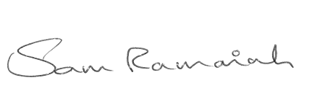 |  | 

Prof Sam Ramaiah | Dave Martin | Pauline Pilkington MBE
Director of Public Health | Director of Social Care & Inclusion | Director of Children’s Services
NHS Walsall | Walsall Council | Walsall Council

1 Introduction

The Director of Public Health, Director of Adult Social Services and Director of Children’s Services are charged by the Department of Health with leading the Joint Strategic Needs Assessment (JSNA) of the health and well-being needs of their population on behalf of their respective organisations, with significant input from the Local Strategic Partnership.

The JSNA process builds on a long history of needs assessment and priority setting in Walsall. The first Walsall JSNA (2008) was developed from the combined efforts of Walsall Council, Walsall Local Strategic Partnership and NHS Walsall. The basis was the DH guidance to collate a core set of data about the Borough and its people and to scrutinise existing strategies to check their likely impact on improving health, well-being and life chances of the population in Walsall.

Joint Strategic Needs Assessment - January 2009

In undertaking this update of the JSNA all agencies have reviewed their contributions to addressing the strategic priorities highlighted in the first JSNA summary document. In so doing, further challenges for the Borough have been identified. In addition, new and updated data is available for a number of items included in the initial assessment and addressing weaknesses and gaps identified through stakeholder consultation in December 2008.

This update is intended to inform readers about the headline priorities for Walsall. However, the importance of more in-depth intelligence is also acknowledged as being extremely valuable. For this reason, much of the data included is also available to view interactively through NHS Walsall Public Health’s Instant Atlas software. Instant Atlas is a visual way of displaying data geographically and allows a user to compare areas and look at trends over time. To access the interactive maps, click on the link below:



Improving health, well-being and life chances and independence remain the key strategic priorities for improving the health and well-being of people in Walsall across the NHS, Local Authority and the Walsall Partnership.

In order to be an effective tool in improving health, well-being and life chances the JSNA needs to inform priority setting, selection of outcome indicators, commissioning decisions and monitoring and management of performance within each partner agency and across the partnership, primarily through the Local Area Agreement.

Figure 1 JSNA as part of the strategic commissioning cycle

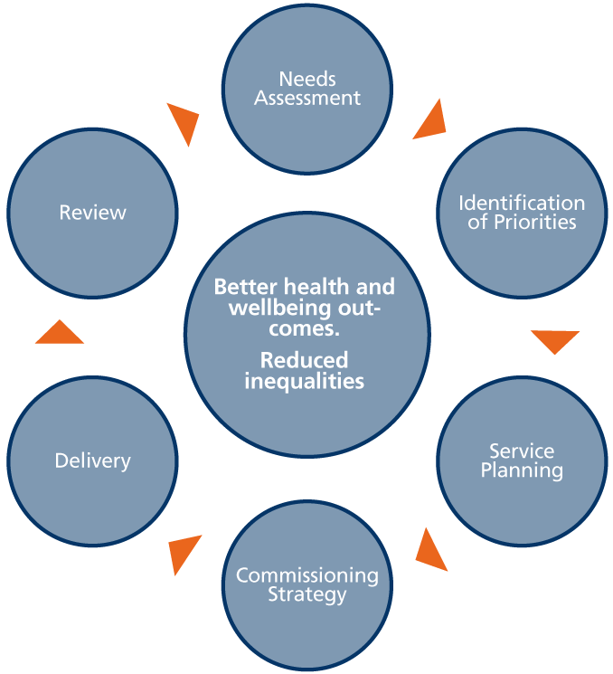

2 People and Places: The People Who Live in Walsall

The Changing Population of Walsall

Figure 2 Walsall Population Projections, by Age 2006 to 2026
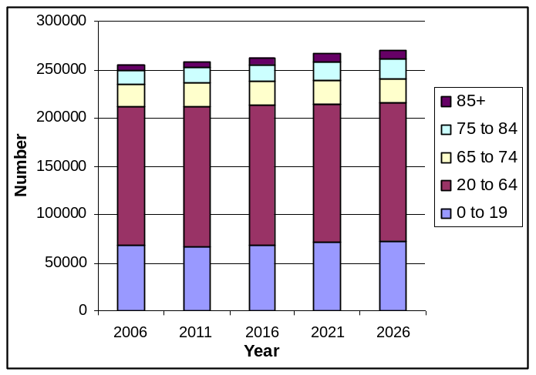 | Walsall’s population is predicted to increase by 6% over the next 20 years from 254,600 in 2006 to 270,100 in 2026.  The proportion of the population 65 years and older is predicted to increase by 27%, with the number of people 85 years and older more than doubling from 4,700 in 2006 to 9,600 in 2026.
Source – ONS

Key message

Promoting healthy ageing, ‘adding life to years’ and planning increased capacity to meet the needs of a growing number of older people are key strategic priorities in Walsall.

Link to further information:
http://www.walsallpartnership.org.uk/wp-index/wbspwp_useful_documents/wp_jsna.htm

Minority Ethnic Groups

Figure 3 Minority Ethnic Groups, 2001, 2007, 2009
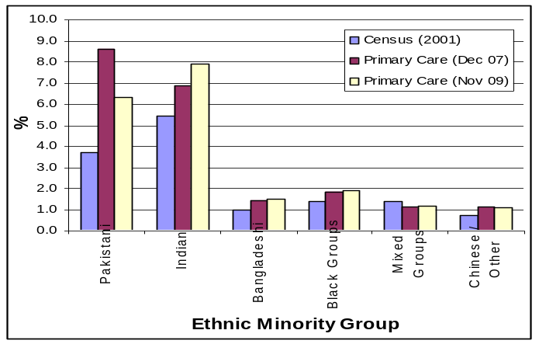 | Indian, Pakistani and Bangladeshi minority ethnic groups form the largest minority ethnic groups in Walsall. Numbers for Indian residents have increased from 5.4% (13,766) in 2001 to 7.9% in 2009 (18,144).  Minority ethnic groups in Walsall are concentrated in deprived areas in the central and southern parts of the Borough, compounding the impact of deprivation.
Source – 2001 Census, CDRIntell

Key message

Access and appropriate provision of services depends on well-informed understanding of the specific needs of these different communities. Skilled interpreters are essential to access at all levels for those lacking fluency in English. Variations in the population estimates from different data sources require further investigation.

Link to further information:
http://www.walsallpartnership.org.uk/wp-index/wbspwp_useful_documents/wp_jsna.htm

Deprivation
Figure 4 Index of Multiple Deprivation in Walsall, 2007
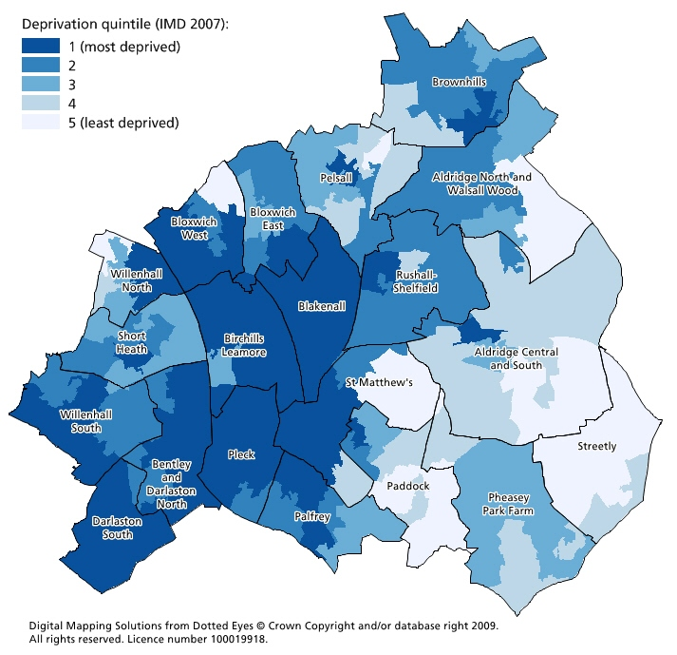 | 7 of the 20 wards in Walsall contain Lower Super Output Areas (LSOA) that are within the most deprived national quintile and 1 ward contains Lower Super Output Areas within the least deprived quintile.  109,266 (43%) of Walsall’s population live within the most deprived quintile compared to 30,015 (12%) living in the least deprived quintile.  There is an 8-year difference in life expectancy between people living in the most deprived compared with those living in the least deprived areas of Walsall .
Source – Communities and Local Government

Key message

Reducing inequalities in health means achieving a more rapid improvement in health and well-being for people living in these deprived areas than those living in the more affluent areas. Partnership agreement on ‘priority areas’ based on a super output area analysis of need would help in targeting resources and action to areas of greatest need.

Link to further information:
http://www.walsallpartnership.org.uk/wp-index/wbspwp_useful_documents/wp_jsna.htm

Headline Indicators

3.1 All Age All Cause Mortality (AAACM) in Walsall

Figure 5 Directly Standardised Mortality Rate from All Causes, 2001-07
Rate per 100,000 Males, All Ages
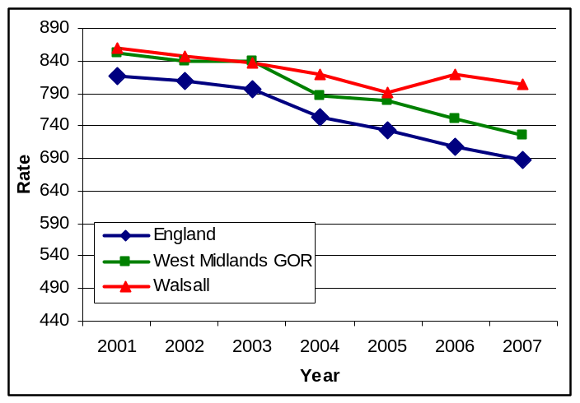 | All age all cause mortality in males for Walsall has gradually decreased over recent years. However, the gap with regional and national comparators has widened over the last 2 years.  Male all age all cause mortality is almost twice as high in Bloxwich East than in wards with the lowest rates such as Palfrey and Pleck.
Source - ONS

Figure 6 Directly Standardised Mortality Rate from All Causes, 2001-07
Rate per 100,000 Females, All Ages
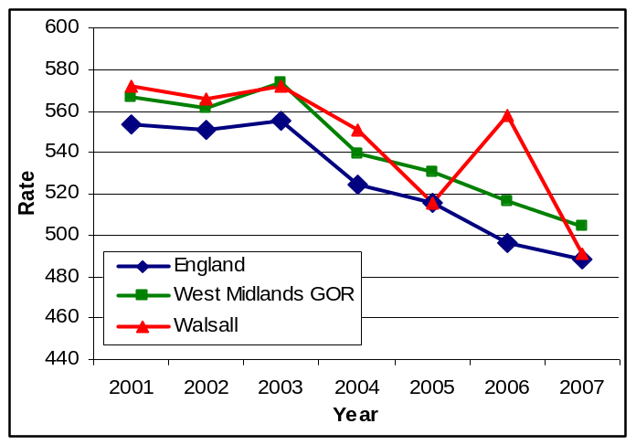 | All age all cause mortality in females in Walsall has reduced significantly over recent years. It is currently below regional levels and almost as low as the national level.  Female all age all cause mortality is more than 2.5 times higher in Bloxwich East than in wards with the lowest rates such as Pheasey Park Farm and Paddock.
Source - ONS

Key message

Despite rates falling by 17% for men and 18% for women since baseline year (1997), Walsall is currently off track for both of these LAA targets, and considerably so in the case of AAACM for men. The Department of Health Benchmarking Tool indicates that NHS Walsall is ‘doing better than predicted’ for these indicators, given the level of deprivation in Walsall.

3.2 Life Expectancy: Males in Walsall

Figure 7 Life Expectancy at Birth in Walsall – Males, 1991-2007
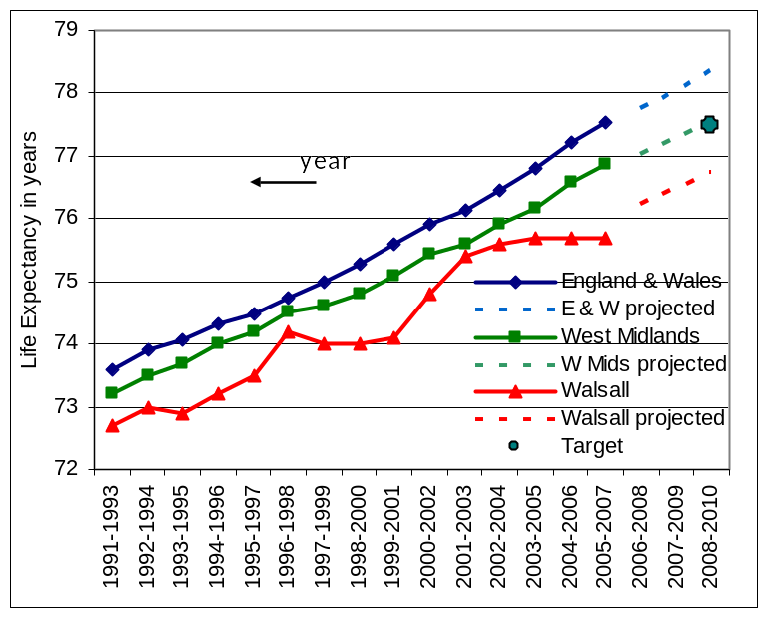 | Male life expectancy in Walsall is 1.8 years less than the average for England and Wales and the gap is getting wider.  In contrast to the national trend, improvements in average life expectancy in men in Walsall have stalled since 2001. There is also unacceptable variation in male life expectancy across the Borough.  To meet the year 2010 target, life expectancy for Walsall men needs to increase from 75.7 to 76.7 years.
Source – ONS, NCHOD

3.3 Life Expectancy: Females in Walsall

Figure 8 Life Expectancy at Birth in Walsall – Females, 1991-2007
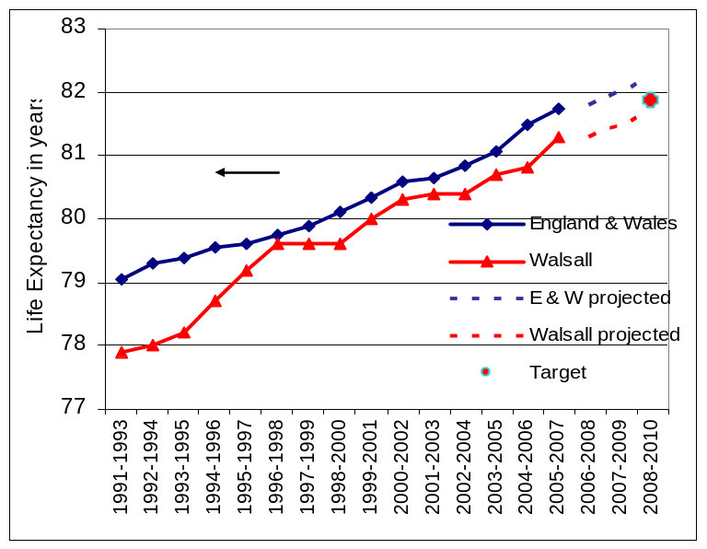 | Female life expectancy in Walsall is 0.4 years less than the average for England and Wales.  To meet the 2010 year target, life expectancy for Walsall women needs to increase from 81.3 to 81.7 years.
Source – ONS, NCHOD

Life expectancy in Walsall is below national average for both men and women. Current trajectories indicate that Walsall is slightly off track in terms of meeting the 2010 PSA target for female life expectancy.

Key message

Improving the health and life expectancy of men in Walsall is a priority of the Walsall Joint Health Inequalities Strategy.

Link to further information:
http://www.walsallpartnership.org.uk/wp-index/wbspwp_useful_documents/wp_jsna.htm

Strategic Priorities for Improving Health and Well-being
Building on the work undertaken for the JSNA, the following strategic priorities have been agreed:

4.1 Improving Health and Life Chances for Babies, Children and Young People
4.2 Improve, Prevention and Early Detection of Major Killers to Improve Life Expectancy
4.3 Living Healthy Lives with Long-term Illness
4.4 Promoting Healthy Ageing
4.5 Reducing Inequalities in Lifestyle
4.6 Promoting and Improving Well-being, Mental Health and Quality of Life
4.7 Promoting Independence, Social Isolation, Care and Safeguarding Vulnerable People
4.8 Prosperity: Improving Life Chances for the People of Walsall

An introduction to the key work streams in each of these programmes and signposting to more detailed strategy documents and action plans is given in the following sections.

Improving Health and Life Chances for Babies, Children and Young People

4.1.1 Giving a healthy start to life to all babies born and living in Walsall

Figure 9 Infant Mortality rates, 3 Year Rolling Averages 1995-2007 | Figure 10 Infant Mortality by Ward  Rate per 1,000 Live Births
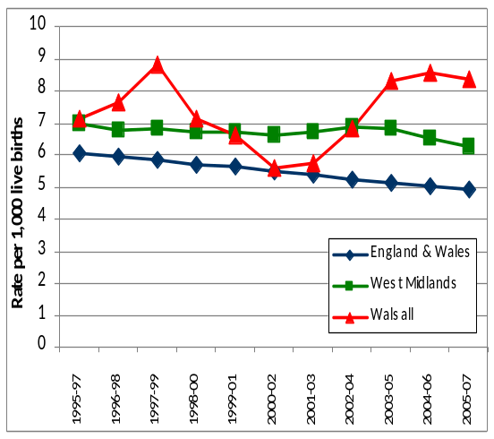  Walsall’s infant mortality rate has been rising since 2000-02 and current projections indicate that this is likely to continue if action is not taken. | 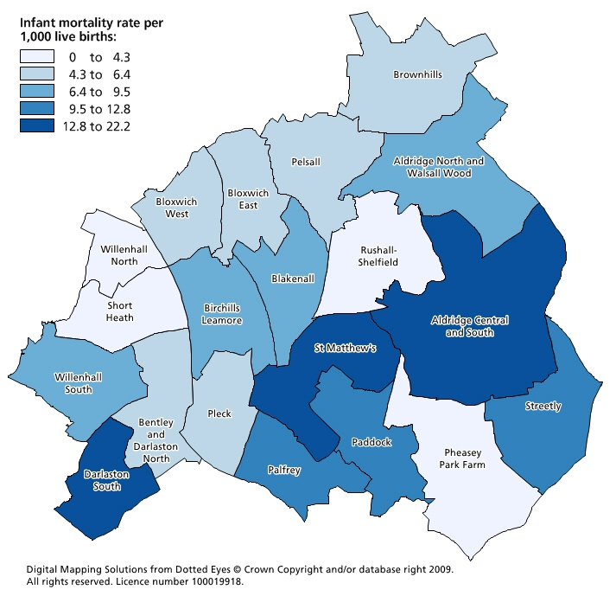  Depending on where a baby is born in Walsall, infant mortality varies from 0 per 1000 (Pheasey Park Farm & Short Heath) to 22 deaths per 1,000 births (Darlaston South)
Source - ONS

Key message

These unacceptable inequalities are a priority for local action. Action to reduce infant mortality is essential in achieving the strategic priorities of giving a healthy start to life for all babies born in Walsall and contributes to improving life expectancy and reducing the overall mortality rate. The agreed action plan calls for action across seven key themes.

Link to further information:
http://www.walsallpartnership.org.uk/wp-index/wbspwp_useful_documents/wp_jsna.htm

4.1.2 Teenage pregnancy and sexual health

Figure 11 Under 18 Conception Rates (per 1,000 females aged 15 – 17 years), 1998-2007
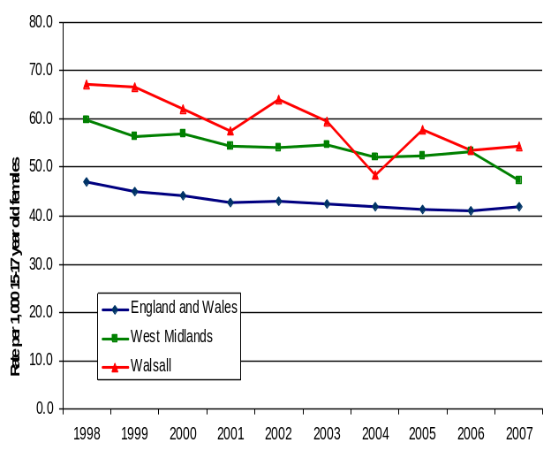 | Teenage conceptions rates in Walsall, have significantly reduced since 1998, although there has been a slight increase locally and nationally in 2007.  In 2007 there were 287 teenage conceptions in Walsall, of which 55% (158) led to births. This compares to 273 conceptions in 2006 and 60% (164) leading to births.
Source – ONS, Teenage Pregnancy Unit

Key message

There are many associations between teenage pregnancy and child poverty, worklessness, poorer health outcomes and restricted aspirations. Effective action to reduce numbers of conceptions and births to teenage mothers will also have an impact on achieving other strategic priorities.

Link to further information:
http://www.walsallpartnership.org.uk/wp-index/wbspwp_useful_documents/wp_jsna.htm

4.1.3 Obesity in childhood

Figure 12 Percentage of Obese Children in Reception and Year 6 Combined by ward, 2006/7 to 2008/09
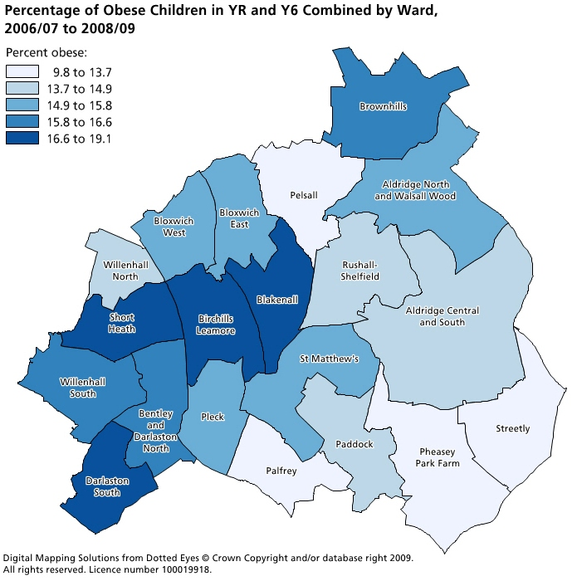 | Over 9,000 children aged 1-15 yrs old are obese in Walsall.  The prevalence of obesity in year 6 children is above the national average and a greater than 2% increase in prevalence has been recorded over the last three years.  The highest levels of childhood obesity are present in the most deprived areas of Walsall.
Source - NCMP

Key message

Based on current trends, the LAA target will not be met. A sustained partnership approach is required to tackle childhood obesity in Walsall.

Link to further information:
http://www.walsallpartnership.org.uk/wp-index/wbspwp_useful_documents/wp_jsna.htm

Improve, Prevention and Early Detection of Major Killers to Improve Life Expectancy

4.2.1 Prevention and early detection of circulatory disease

Figure 13 Directly Standardised Mortality Rates from Circulatory Disease, 1995-2007
Rate per 100,000 Persons Aged Under 75
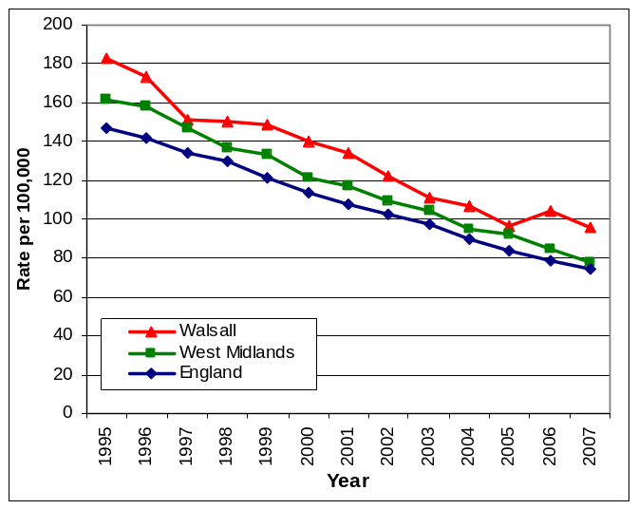 | More people in Walsall die from heart disease than any other illness or event. Premature deaths from heart disease have declined over the past ten years. However, the rates in men have fallen more slowly than elsewhere in the West Midlands.  In men, a 39% reduction has been achieved in 10 years but Walsall mortality in men remains 30% above the England average.  In women, a 48% reduction has been achieved in 10 years but Walsall mortality in women remains over 12% higher than the England average.
Source - ONS

Key message

There are very effective actions that can prevent heart disease as well as treat established disease. Stopping smoking leads to immediate and sustained improvements in health and reduced risk of death. All agencies can take actions to reduce the promotion of smoking and to support people to take more physical exercise.

Link to further information:
http://www.walsallpartnership.org.uk/wp-index/wbspwp_useful_documents/wp_jsna.htm

4.2.2 Prevention and early detection of cancer

Figure 14 Directly Standardised Mortality Rate from Cancer, 1995-2007
Rate per 100,000 Persons Aged Under 75
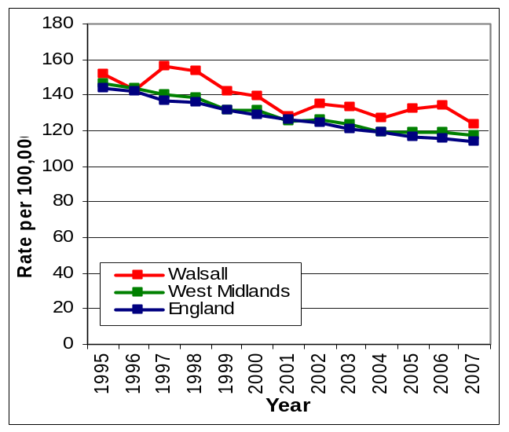 | Premature deaths from cancer in Walsall have gradually reduced over time but national rates have fallen marginally faster and the gap between Walsall and the national rate has widened between 1995-97 and 2005-07.  More than a third more men than women die prematurely from cancer in Walsall, which is similar to the national ratio of male/female cancer deaths.  Mortality for men in Walsall remains 17.5% above the England average, despite a 16% reduction in Walsall in 10 years; mortality for women also remains 6.7% above the England average, despite an 11% reduction over 10 years.
Source - ONS

Key message

The prevention of cancer is important for all. The biggest contributor to this across all agencies is to aggressively reduce the number of people taking up and continuing to smoke tobacco.

Link to further information:
http://www.walsallpartnership.org.uk/wp-index/wbspwp_useful_documents/wp_jsna.htm

Living Healthy Lives with Long-term Illness

4.3.1 Living with cardiovascular disease

Figure 15 Age Standardised Mortality Rate from Coronary Heart Disease, Persons aged 65 to 74
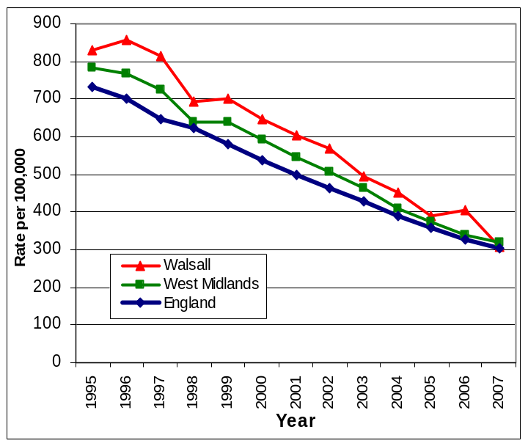 | For more than a decade there has been a relatively steady decline in this mortality rate. By 2005-07, a 58% reduction had been achieved from a 1995/1997 baseline, resulting in 109 fewer annual deaths.  The national target of at least a 40% reduction by 2010 has therefore already been achieved in Walsall. In addition, Walsall has also achieved its more demanding local target of a 50% reduction by 2010. Nevertheless, in 2005-07 Walsall’s mortality rate remains 15% above the England average.
Source – Compendium of Clinical and Health Indicators

Key message

Action is targeted to groups within the population with the highest risk of heart disease including smoking cessation, weight management and NHS Health Checks programme. These will contribute to addressing the poor health outcomes and inequalities, especially for men.

Link to further information:
http://www.walsallpartnership.org.uk/wp-index/wbspwp_useful_documents/wp_jsna.htm

4.3.2 Living with diabetes

Figure 16 Estimated Diabetes Prevalence by Ward, 2007/08
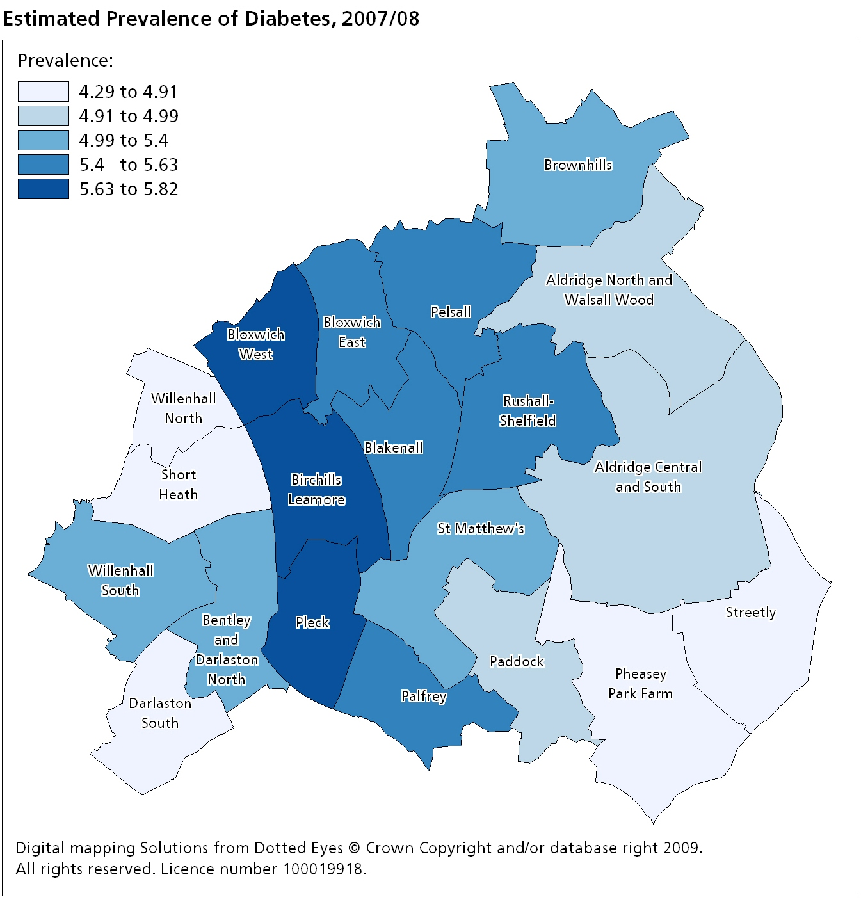 | Walsall has one of the highest rates of diabetes of all PCTs in England. There are currently over 14,000 people in Walsall with diabetes. People with diabetes are at an increased risk of developing cardiovascular disease and efforts should be made to reducing this risk. Diabetes is the commonest cause of blindness and there is evidence that many people with diabetes do not understand the impact of their disease until they face loss of sight and limb amputations.  Pleck in the South has the highest prevalence of diabetes. Around 40% (5,600) of the population of Pleck are from an ethnic minority group and an estimated 28% of adults are obese.
Source - QOF

Key message

Key actions that partners can take to reduce obesity and smoking in our population will have a great impact on the burden of this disease on health and social care.

Link to further information:
http://www.walsallpartnership.org.uk/wp-index/wbspwp_useful_documents/wp_jsna.htm

4.3.3 Living with chronic obstructive pulmonary disease (COPD)

Figure 17 Estimated COPD Prevalence by Ward, 2007/08
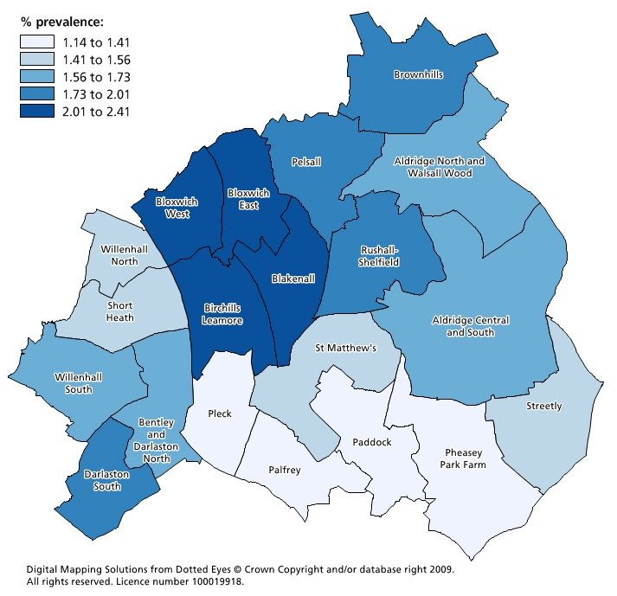 | COPD is the second largest cause of emergency hospital admission in the UK and is one of the most costly inpatient admissions treated by the NHS.  The number of Walsall patients registered with COPD is 4824 (1.8 % prevalence-QOF 08/09 data). However, the actual prevalence is likely to be higher. Hospital admissions for COPD in Walsall average 750 per year but have increased in recent years. COPD is the 3rd largest cause of hospital admission in Walsall, after cancer and CHD.  Deaths from COPD in Walsall remain relatively static at an average of about 140 deaths a year. Nevertheless, COPD remains the 4th most common cause of death after cancer, CHD and stroke.
Source - QOF

Key message

Reducing smoking prevalence in the Borough would have the greatest impact on reducing COPD and its impact on local services in Walsall. Other actions which can minimise the exacerbation of COPD include safer industrial processes and improved air quality across the Borough.

Link to further information:
http://www.walsallpartnership.org.uk/wp-index/wbspwp_useful_documents/wp_jsna.htm

Promoting Healthy Ageing

4.4.1 Prevention and management of stroke

Figure 18 Estimated Stroke Prevalence by Ward, 2007/08
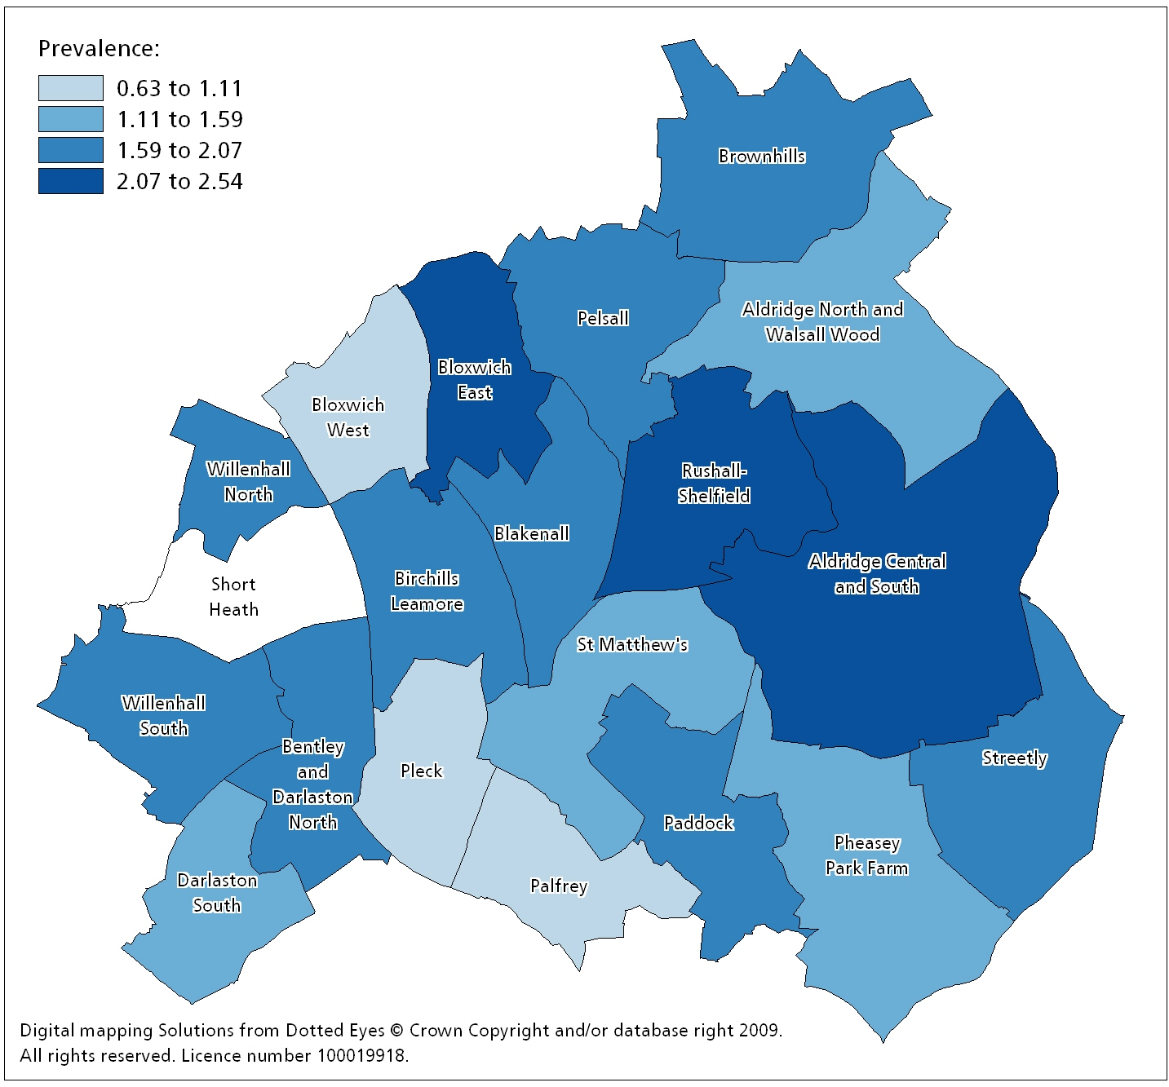  Note – data is missing for Short Heath ward due to there not being a practice in this area. | As with CHD, the estimated prevalence of stroke patients by ward is highest in the North and East areas of Walsall. These areas also have the oldest population. The prevalence is lower in the South, in particular in Palfrey and Pleck.  Prevalence ranges from 0.64% in Palfrey up to 2.5% in Bloxwich East with a Borough-wide average prevalence of 1.6%.  Similarly to CHD, several practices may specialise in treating patients with chronic heart conditions and therefore large stroke registers may have skewed these practice-based prevalence estimates.
Source – QOF

Key message

Ensuring good control of blood pressure and heart rhythm disorders will have a great impact on the number of people who develop stroke. Fast action when symptoms develop can make a major contribution to reducing long term disability.

Link to further information:
http://www.walsallpartnership.org.uk/wp-index/wbspwp_useful_documents/wp_jsna.htm

4.4.2 Prevention and management of falls and fractured neck of femur

Figure 19 Admission Trends from Fractured Neck of Femur, 2001-2009
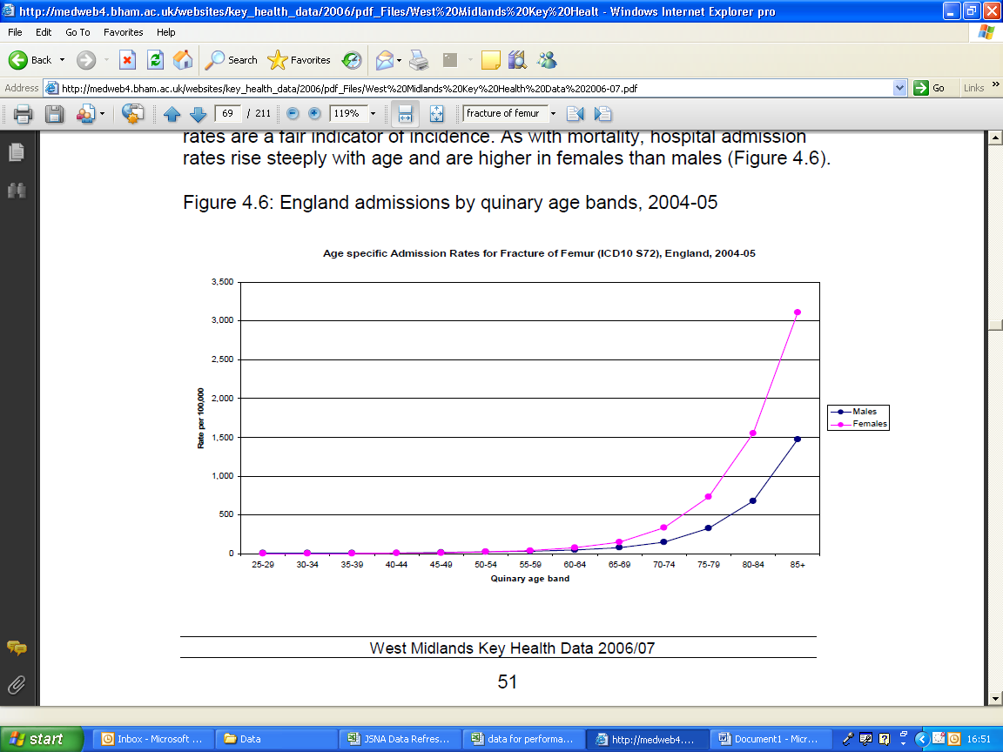 | Hospital admissions from fractured neck of femur (broken hip) rises steeply with increasing age, especially in those over 85 years. Fractured neck of femur is an important cause of death, disability and loss of independence in older people.  The proportion of people operated on within 48 hours and proportions regaining independence following fracture are key quality and outcome indicators
Source – West Midlands Key Health Data 2006/07

Key message

Effective measures to maintain an active lifestyle among older people, to improve bone health, early detection and management of osteoporosis and comprehensive and accessible falls prevention programmes will all contribute to the health, well-being and independence in older age. A local strategy is required to inform and drive action.

Link to further information:
www.bham.ac.uk
http://www.walsallpartnership.org.uk/wp-index/wbspwp_useful_documents/wp_jsna.htm

4.4.3 Early detection and management of dementia

Figure 20 Estimated Numbers of People in Walsall with Dementia, 2007-2017
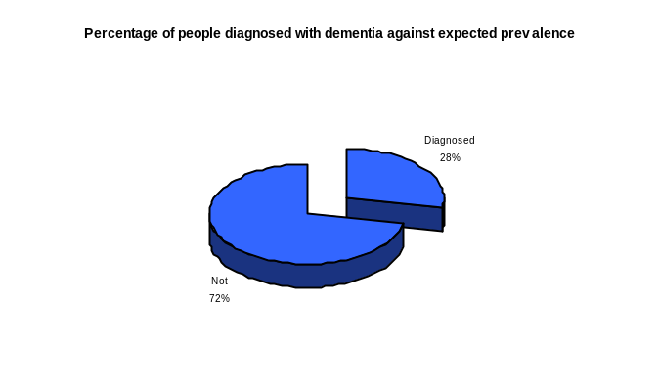 | Population changes indicate that there will be a marked increase (25.3%) in the number of people with dementia over the next ten years, reflecting the growing numbers of older people.  Fewer than 28% of people estimated to have dementia in Walsall have been diagnosed. Of these, more than half may never receive a diagnosis. Of those who do receive a diagnosis, they will have most likely suffered from dementia for more than three years.
  Age-group | 2007 | 2012 | 2017
  30-64 | 79 | 76 | 65
  65-69 | 183 | 196 | 184
  70-74 | 286 | 296 | 322
  75-79 | 581 | 585 | 659
  80-84 | 752 | 836 | 953
  85+ | 1,257 | 1,417 | 1,806
  TOTAL | 3,137 | 3,406 | 3,999
Source – QoF Data 2008-2009

Key message

Dementia is a major cause of loss of independence in older age and a significant burden on formal and informal carers. Earlier diagnosis of dementia will enable earlier intervention help to maintain function, slow deterioration, support carers and reduce inappropriate emergency admissions to acute hospital care.

Link to further information:
http://www.walsallpartnership.org.uk/wp-index/wbspwp_useful_documents/wp_jsna.htm

4.4.4 Reduction of excess winter deaths (EWD)

Figure 21 Excess Winter Deaths Index, 2006-2008
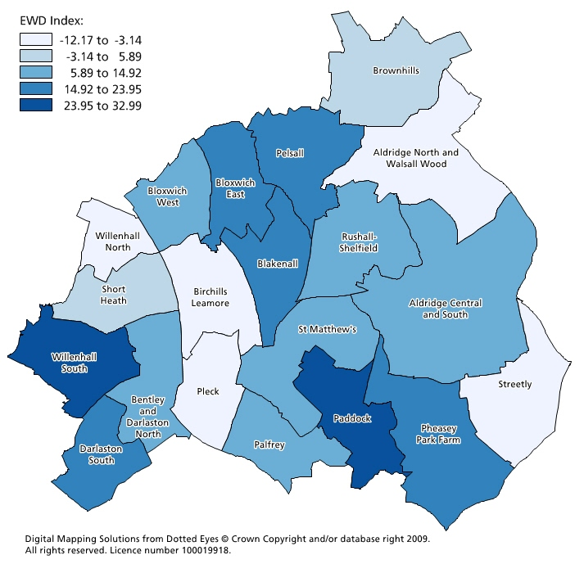 | There is a 20% difference in EWDs between the coldest and warmest homes.  80% of excess winter deaths are due to the cold.  Over half of EWD deaths are from cardiovascular disease and a third are from respiratory disease; most are preventable.  EWDs are significantly more likely in residents of:  - privately rented and owner-occupied homes  - houses built before 1850  - damp houses.
Source - ONS

Key message

Preventing excess winter deaths is an important strand of reducing All Age All Cause mortality and increasing life expectancy. Private sector housing is a priority area for the targeting of interventions, including falls prevention and tacking fuel poverty. Vulnerable Persons Registers need to be used more effectively by partners, to ensure systematic identification of those at risk.

Link to further information:
http://www.walsallpartnership.org.uk/wp-index/wbspwp_useful_documents/wp_jsna.htm

Reducing Inequalities in Lifestyle

4.5.1 Reducing smoking prevalence

Figure 22 Number of adults* in Walsall smoking in last 15 months, 2009
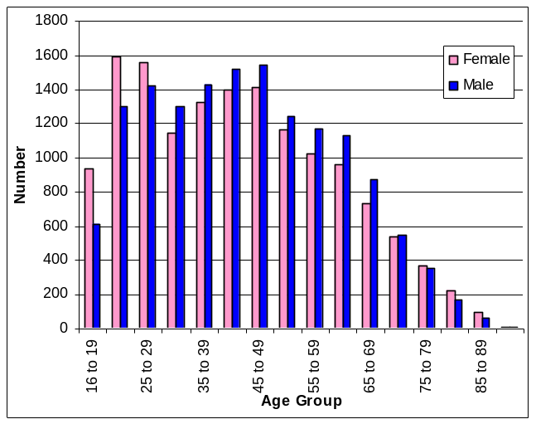 | Smoking peaks in the younger age groups from 20 to 49 years. 50 years and over, numbers reduce quite considerably.  Smoking amongst those aged 16 or over in Walsall is more common amongst females from age 16 to 29. From 30 years onwards, it is more popular with males.  About 1 in 5 adults are smokers and more than a quarter of children live in a household where someone smokes.  Smoking prevalence across Walsall is strongly associated with levels of deprivation.
Source – CDRIntell
* - those aged equal to or greater than 16

Figure 23 Smoking Prevalence Among Adults, 2005
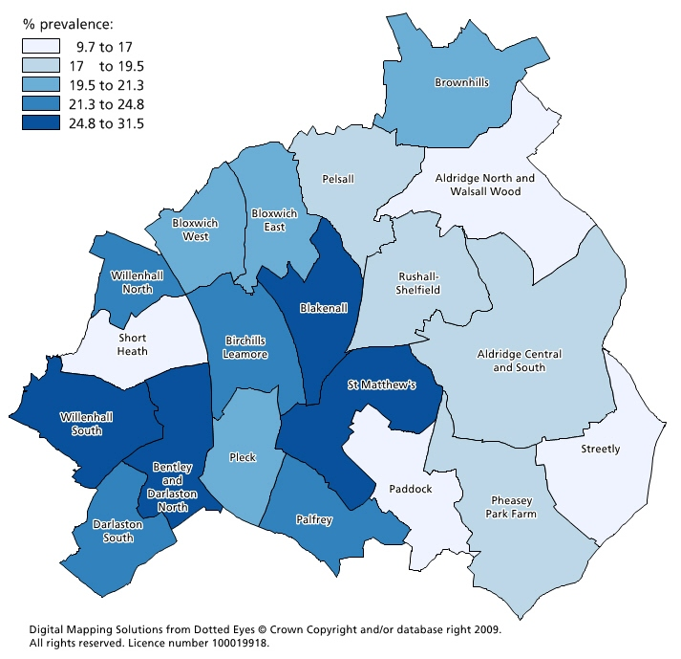 | 21% of men and 20% of women in Walsall who responded to the 2005 Regional Lifestyle Survey indicated that they were smokers. More than a quarter of children live in a household where someone smokes.  The 2005 survey indicated substantial variation in smoking prevalence across wards in Walsall, ranging from 10% in Aldridge North and Walsall Wood to over 30% in Blakenall and Bentley and Darlaston North. As elsewhere, smoking prevalence across Walsall is strongly associated with levels of deprivation.
Source – WMRLS, 2005

Key message

Smoking remains the leading cause of preventable morbidity and premature death, contributing to more than 400 deaths per annum in Walsall. Smoking is the single greatest contributor to health inequalities and accounts for half of the difference in risk of premature death between social classes. Death rates from tobacco use are two to three times higher among disadvantaged social groups than among the more affluent.
More needs to be done to make the most out of every contact front line staff have with smokers, in order to increase referrals to Walsall Stop Smoking Service.

Link to further information:
http://www.walsallpartnership.org.uk/wp-index/wbspwp_useful_documents/wp_jsna.htm

4.5.2 Physical activity in adults

Figure 24 % adults participating in sport and active recreation of at least 30 minutes duration on 3 or more days a week, 2005/06 to 2008/09
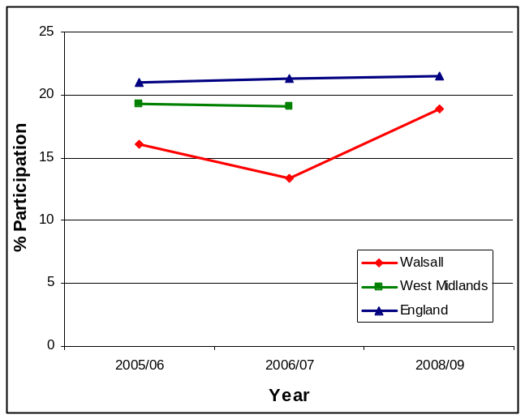 | Walsall has the lowest participation rate for adults (16 and over) participating in sport and active recreation for at least 30 minutes on 3 or more days of the week compared to regional and national levels. However, participation levels have increased to 18.9% in 2008/09 compared to the baseline of 16.1% in 2005/06.
Source – WMRLS, 2005

Key message

The Walsall Partnership has prioritised adult physical activity through selection of LAA National Indicator 8. This measures the percentage of the adult population (16 plus) who participate in sport and active recreation, at a moderate intensity for at least 30 minutes on 3 or more days of the week.
Within Walsall the baseline measure in 2006 identified that only 16.1% of residents were active to that level compared to a national figure of 21.3%. The most recent survey shows an improvement to 18.9% compared to a national average of 21.5%. However this data should only be interpreted as a direction of travel prior to the next full release of Active People in December 2009.

Link to further information
http://www.walsallpartnership.org.uk/wp-index/wbspwp_useful_documents/wp_jsna.htm

4.5.3 Obese or overweight levels in adults

Figure 25 Number of adults* in Walsall with a BMI greater than or equal to 30 in last 15 months, 2009
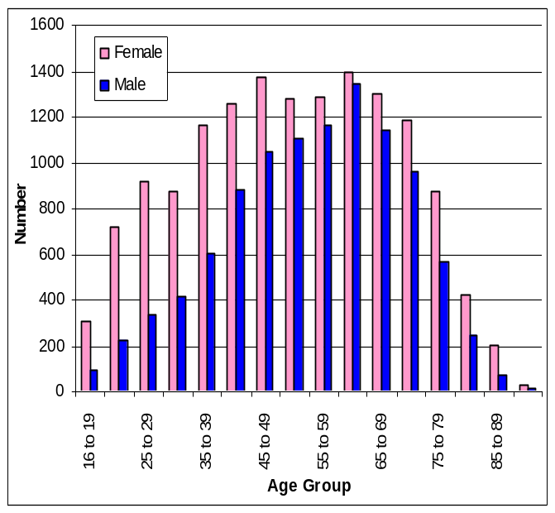 | In all age groups in Walsall, more females than males are recorded as having a BMI of 30 or more.  BMI of 30 or more peaks at 60 to 64 for males but remains consistently high for females until age 65 to 69.  More than half of Walsall adults are estimated as obese or overweight – about 113,000 people.  In 5 wards over 60% of adults are obese or overweight.  Obesity is more prevalent in the more deprived areas. However, overweight prevalence is higher among more affluent socio-economic groups.
Source – CDRIntell
* - those aged equal to or greater than 16

Figure 26 Percentage of Adult Population Obese or Overweight by Ward, 2005
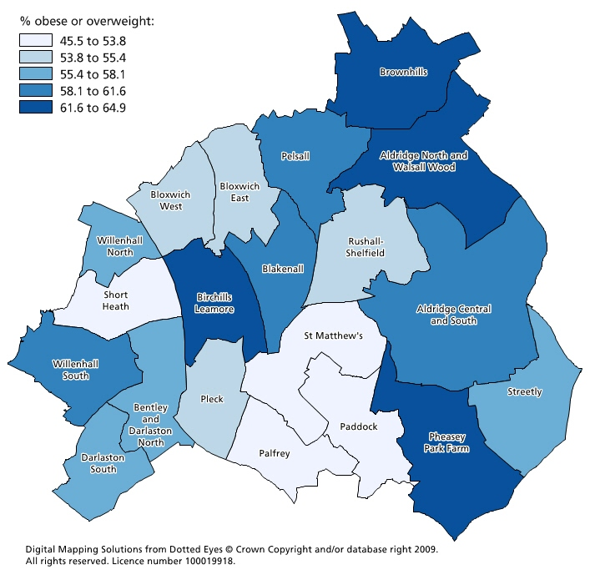 | In Walsall, it is estimated that between 37,000 (19%) and 66,000 (33%) of adults are obese and up to 57% are overweight or obese.  In five wards over 60% of adults are obese or overweight.  National data shows that obesity is more prevalent in more deprived communities.
Source – WMRLS, 2005

Key message

Obesity is a significant cause of chronic ill health and increases the risk of diabetes, coronary heart disease and cancer. Obesity is associated with an average nine year reduction in life expectancy. It also strongly linked to infant mortality.

Without action, overweight and obesity-related diseases will cost NHS Walsall an estimated £82 million per year by 2015. In spite of this, Walsall currently has no targets in place to reduce the prevalence of obesity in adults.

There is an adult weight management pathway in place; however demand is such that a more sustainable approach is required in the form of greater investment in activities that focus on primary prevention of obesity.

Compared with childhood obesity data, data relating to the prevalence of adult overweight and obesity in Walsall are of poor quality. There is a clear need to improve local surveillance data.

Link to further information:
http://www.walsallpartnership.org.uk/wp-index/wbspwp_useful_documents/wp_jsna.htm

Promoting and Improving Well-being, Mental Health and Quality of Life

4.6.1 Alcohol related health harm

Figure 27 Rate of hospital admissions per 100,000 for alcohol related harm, 2008/09
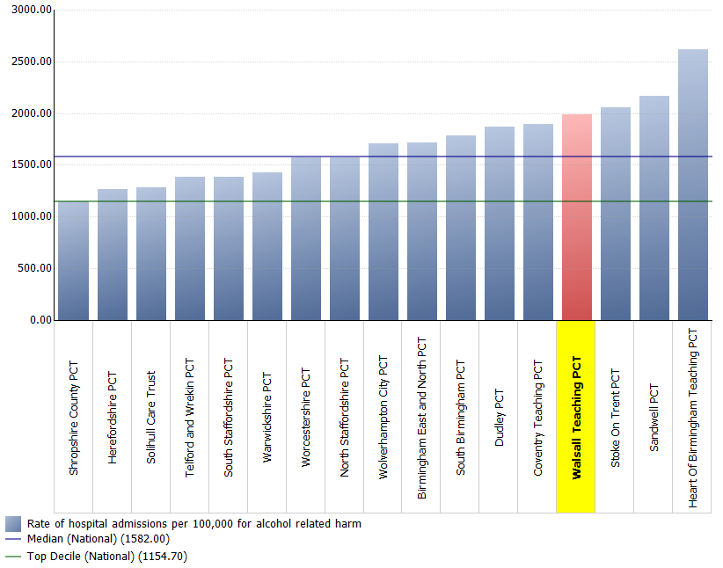 | Walsall is amongst the highest of primary care trusts in relation to hospital admissions for alcohol related harm (with a rate of 2000.00 per 100,000 population). Walsall’s rate is considerably higher than the national average of 1582.00.
* see needs assessment for definitions

Key message

The scale of alcohol misuse in Walsall has wide-reaching effects on the health and well-being of adults, children, families and communities in Walsall. Co-ordinated partnership action and additional investment in alcohol prevention and treatment services are likely to be required to achieve impact on this problem

Link to further information:
http://www.walsallpartnership.org.uk/wp-index/wbspwp_useful_documents/wp_jsna.htm

4.6.2 Suicide prevention

Figure 28 Age Standardised Mortality Rates (3 year averages) for Suicide and Undetermined Injuries, Persons All Ages, 1995-2007
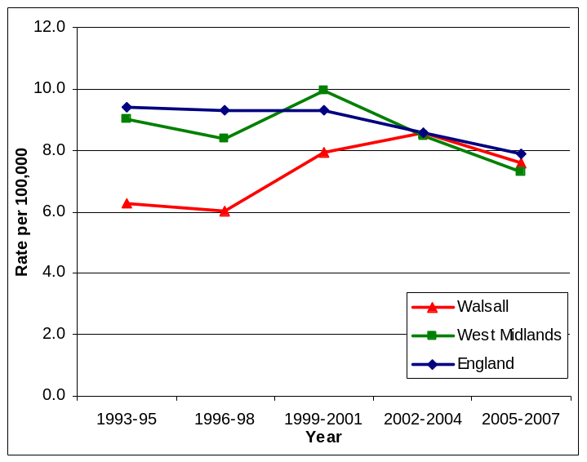 | In the 1995-97 baseline period, Walsall’s mortality rate was well below the regional and national average and was already below the national target rate for 2010.  Over time, Walsall’s rate has varied. Recent 2005-2007 figures show that Walsall is below the national rate but has risen slightly above the regional rate. There is an average of 18 deaths per year in Walsall from this cause.
Source - Compendium of Clinical and Health Indicators

Key message

The actions required to prevent suicide overlap with those required to promote well-being and positive mental health. The recent publication of a new national mental health strategy based on the ‘New Horizons’ consultation provides an opportunity to review and update the current local strategy.

Link to further information:
http://www.walsallpartnership.org.uk/wp-index/wbspwp_useful_documents/wp_jsna.htm

4.6.3 Community safety and fear of crime

Figure 29 How safe residents feel when outside in their local area, 2008/09
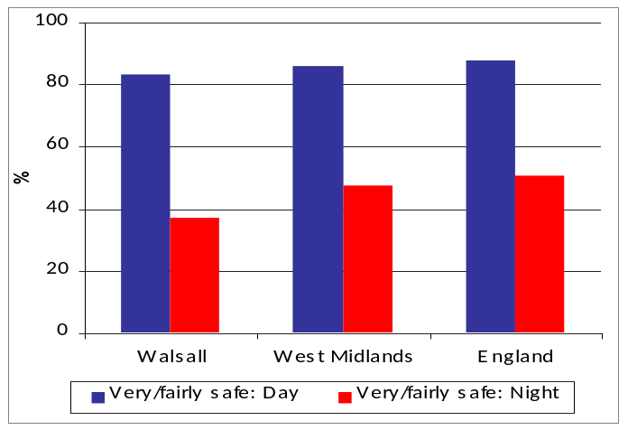 | Generally, Walsall residents feel much safer when out in their local area during the day, with 83.1% feeling ‘very’ or ‘fairly’ safe compared with only 37.2% feeling the same way at night.  Residents in Walsall feel less safe in their local area during both the day and night than the regional and national average: in England overall, just over half of people feel ‘very’ or ‘fairly’ safe at night.
Source – Place Survey, 2008/09

Figure 30 Residents’ perceptions of anti-social behaviour, 2008/09
 | Over a quarter of residents believe anti-social behaviour is a problem in their area, which is higher than both the regional and national figure.  The Place Survey shows 68% of Walsall’s residents feel that the most important Council priority should be to ensure that citizens are safe and secure. In West Midlands Police’s Feeling the Difference survey, 70% of people felt that feeling safe was the most important factor in making somewhere a good place to live, but only 53% of respondents felt Walsall had this attribute.
   | Walsall | West Midlands | England
  % of people who think that anti-social behaviour is a problem in their local area (NI 17) | 26.1 | 21.0 | 20.0
Source – Place Survey, 2008/09, Safer Walsall Partnership Strategic Assessment 2009/10

Key message

There is a greater feeling of vulnerability amongst Walsall’s residents than there is regionally or nationally, with people more concerned about anti-social behaviour and their personal safety. This has an impact on their quality of life.

Link to further information:
http://www.walsall.gov.uk/wp_borough_tasking

Promoting Independence, Social Isolation, Care and Safeguarding Vulnerable People

4.7.1 People living on incapacity benefit

Figure 31 Trend in Incapacity Benefit Claimants in Walsall by Age, 2005-2009
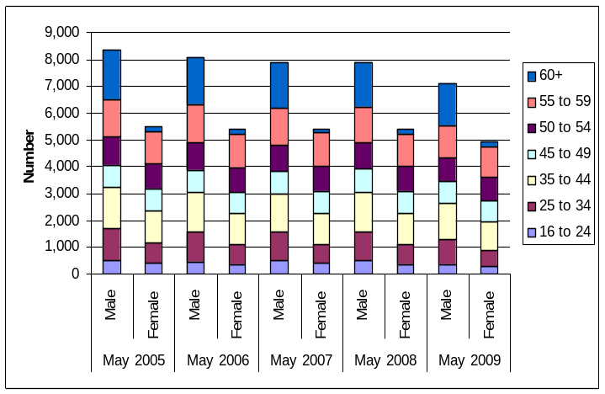 | Numbers of Incapacity Benefit claimants are higher amongst males than females in Walsall.  Over the last 5 years, claimant numbers have steadily reduced from 8,360 in 2005 for males to 7,140 in 2009 and for females from 5,510 to 4,930.  This benefit is claimed more commonly by older age groups (1,740 for over 60’s compared to 650 for 16 to 24 year olds).
Source – NOMIS / DWP

4.7.2 People living on disability living allowance

Figure 32 Trend in Disability Living Allowance Claimants in Walsall by Age, 2005-2009
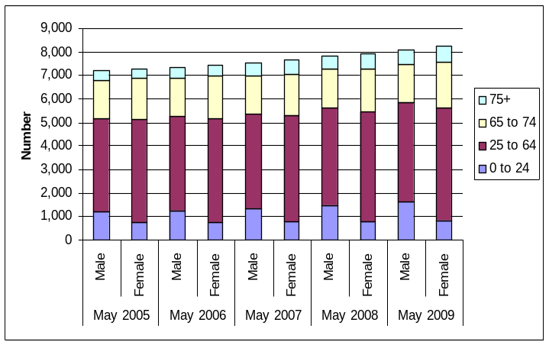 | Disability Living Allowance claimants over the last 5 years in Walsall have gradually increased from 14,500 total claimants in 2005 to 16,360 in 2009.  Most claimants are of working age (9,050 claimants). However, there is also a significant number of people aged over 65 who also claim (4,860 claimants).
Source – NOMIS / DWP

4.7.3 Older people living alone

Figure 33 Older People Living Alone in Walsall, Males and Females Aged 50 and above, 2001
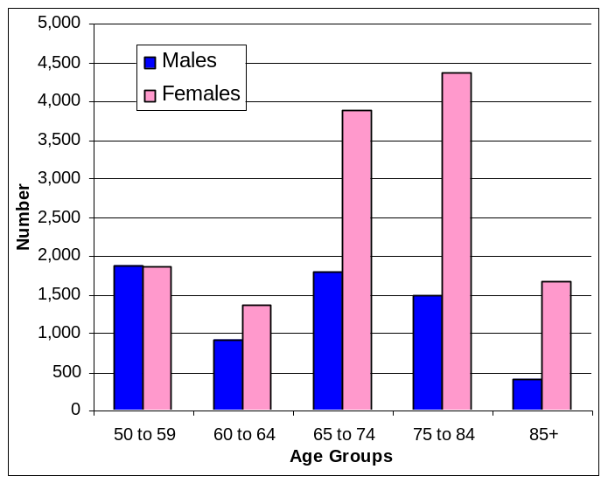 | A greater number of females compared to males are living alone from the age of 60+. A significantly higher number of 75 to 84 year old females are living on their own (4,366 (33%) compared to 1,490 (23%) of those aged 50 and above.
Source – 2001 Census

4.7.4 People living in residential care

Figure 34 Population Living in Residential Care in Walsall, 2001
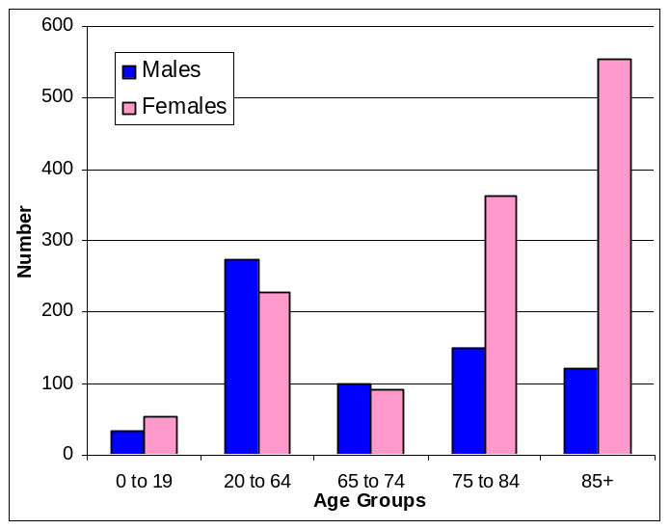 | Amongst the older age groups of 75 to 84 and 85+, there are considerably more females than males living in residential care (363 and 554 compared to 149 and 121 respectively).
Source – 2001 Census

Key message

The level of people in residential and institutional settings in Walsall is above average, particularly people with learning disabilities. There is a need to develop more community based care and support services that provide individuals with a greater opportunity to remain in their own accommodation, and alongside this appropriate support for carers. The programme for self directed care, whereby people are supported to have control over the state funded services that they are entitled, to must be accelerated if it is to reach Government targets. There is a need to develop a preventive services strategy that highlights how universal and mainstream services must reach out to vulnerable people and help them to remain independent of social care and health services with a good quality of life and a range of life chances.

Link to further information:
http://www.walsallpartnership.org.uk/wp-index/wbspwp_useful_documents/wp_jsna.htm

Further information on adults with learning disabilities can be accessed here:
http://www.walsallpartnership.org.uk/wp-index/wbspwp_useful_documents/wp_jsna.htm

Prosperity: Improving Life Chances for the People of Walsall
These are Walsall’s priorities for improving prosperity by tackling the causes and consequences of poverty and worklessness.

Aspiration and attainment

Figure 35 Achievement of 5+ A*-C grade (and equivalent) including English and Maths, 1998-2009
 | Walsall has made substantial progress in improving GCSE attainment.  Despite this, results continue to lag behind the England average which was 49.8% in 2009.
   | 1998 | 2003 | 2008 | 2009
  Walsall | 25.8 | 29.0 | 40.4 | 44.0
Source – DCSF

Key Message

Educational attainment has greatly improved in Walsall in recent years. However, the current achievements still fall below the national average.

Link to further information:
http://www.walsallpartnership.org.uk/wp-index/wbspwp_useful_documents/wp_jsna.htm

Worklessness and skills

Figure 36 Jobseeker’s Allowance Claimants as a % of Working Age Population
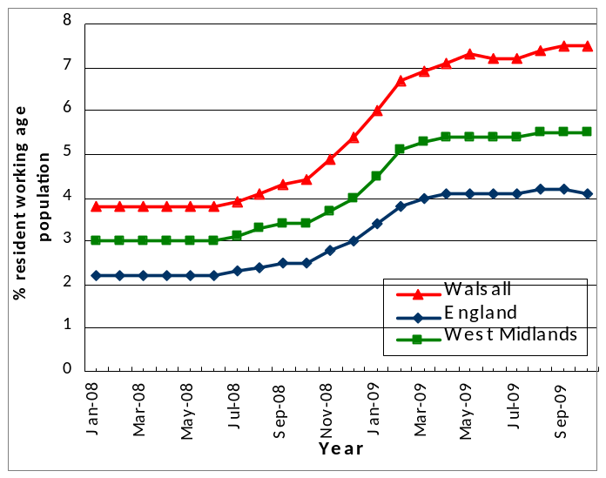 | 11,212 people were claiming JSA in October 2009. This was an increase of 68% on the previous year, and an increase of over 95% on the start of 2008.  Since the start of the economic downturn in mid-2008, worklessness in Walsall has increased at a faster rate than nationally or regionally.
Source – ONS/DWP

Figure 37 Proportion of working age population with qualifications, 2008
* NVQ2 is equivalent to five GCSE passes at A*-C  ** NVQ4 is a first Degree or equivalent | A lower proportion of the working age population in Walsall have educational qualifications than in the region or in Great Britain as a whole.  This lack of skills in the workforce results in lower wages and limited opportunities. It may also be a factor in the faster increase in JSA claimants in Fig. 36.
   | Walsall % | West Mids % | GB  %
  NVQ2* and above | 56.1 | 61.6 | 65.2
  NVQ4** and above | 18.7 | 24.5 | 29.0
Source – NOMIS / ONS Annual Population Survey

Key message

People’s ability to gain access to employment is more limited in Walsall due to lack of skills and opportunities, and the situation is worsening in relation to the national and regional position. This has a knock-on effect on worklessness, income levels and hence poverty. There is a strong correlation between poverty and poor health outcomes.

Link to further information:
http://www.walsallpartnership.org.uk/wp-index/wbspwp_useful_documents/wp_jsna.htm

Young people not in education, employment or training

Figure 38 16-18 year olds not in education, employment or training (NEET) – NI 117
 | Prior to 2009/10 Walsall’s NEET figure had shown improvements. However, this was less than the national average reduction and Walsall has been consistently above the national and regional level and that of its statistical neighbours.  Over the past year, the proportion of young people in Walsall who are NEET has slightly increased, while nationally it has remained stable and regionally there has been some improvement.
   | Q2  2009/10 | Q2  2008/9
  Walsall | 9.1% | 8.7%
  West Mids | 8.6% | 9.0%
  England | 8.2% | 8.2%
Source – Black Country Connexions

Key message

Despite progress in reducing the number of young people in the Borough not in education, employment or training in recent years, the current economic downturn is having particularly negative impact on the number of NEETs in Walsall.

Link to further information:
http://www.walsallpartnership.org.uk/wp-index/wbspwp_useful_documents/wp_jsna.htm

Child poverty

Figure 39 Child Poverty Ward Levels - 2007
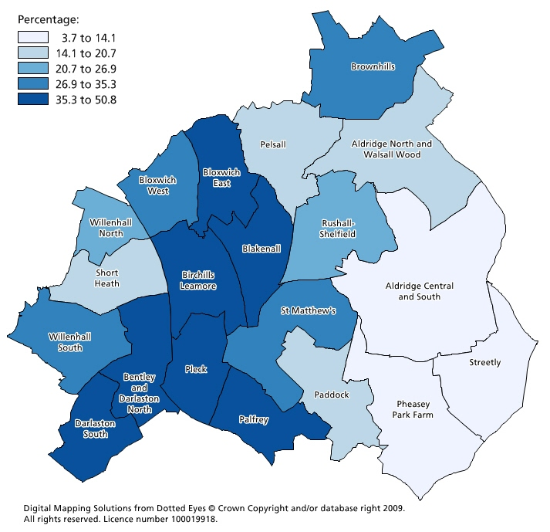 | The 2007 Indices of Deprivation show 26.9% of children in Walsall living in poverty, that is in income deprived households in receipt of workless benefits or tax credits (whose income excluding housing benefits is below 60 per cent of the median before housing costs). This represents around 14,500 children below the age of 16, and is an increase from 24.6% in 2004 (13,500 children).  There are higher concentrations of child poverty in the west of the Borough; and then in 4 wards:  - Palfrey  - Birchills Leamore  - Pleck  - St Matthews*.  Walsall between 2004 and 2007 experienced both an increase in proportion of children living in poverty and an increase in range of poverty. This is evidenced in an increasing divide between the most and least deprived areas.  In Blakenall and Birchills Leamore, almost 50% of children live in poverty, whereas in wards in the east of the Borough such as Streetly, Pheasey Park Farm and Aldridge Central and South, between 3.7% to 11.4% of children live in poverty*.  * Child Poverty in Walsall Version 3, November 2009; Walsall Partnership
Source – IMD, 2007, Department of Communities and Local Government

Key message

Walsall Borough suffers from a high level of child poverty at 25.7% (NI116), higher than the national average; moreover, child poverty has increased in Walsall from 2004-07. Child poverty is a wide spread issue across the Borough with 11 wards (out of 20) that have rates higher than the Walsall average.

When analysed at a Super Lower Output Area (LSOA) level, the situation is seen to be concentrated in the west, with one area that has 75% of children living in poverty. Additionally, Walsall has higher than the national average numbers of children living in benefit dependent or low income households.

The impact of child poverty is well researched and documented. There is evidence that shows child poverty severely limits a child’s development, impacts on their future well-being, results in lower educational attainment and skill levels, creates future risk of worklessness and living with low incomes and having poor health and self-esteem. For this reason, tackling child poverty must be a holistic approach to be successful in tackling the issues that arise from inequality, disadvantage and poverty.

The impact of child poverty is now recognised with a ‘basket’ of child poverty indicators provided by the national Child Poverty Unit and is subject to performance monitoring and measurement. Also, the new Child Poverty Bill 2009 places new duties on the local authority and partners to prepare and publish local child poverty needs and strategy. These all reflect the government’s commitment to eradicating child poverty by 2020.

In Walsall the agreed approach is to break the cycle, which is central to success in the long term, working in 3 key areas:
- Mitigate against the effects of child poverty (immediate impact)
- Reduce parental worklessness & low income (immediate/short term impact)
- Raise aspirations (medium/long term impact).

Priorities are:
- Reduce parental worklessness by assisting parents into sustainable employment
- Address in work poverty by assisting parents to raise their skills levels and opportunities for raising their income
- Reduce health inequalities experienced by children and families
- Promote financial inclusion – priority is to help parents and families take up all benefits and tax credits they are entitled to
- Reduce fuel poverty experienced by Walsall households.

Link to further information:
http://www.walsallpartnership.org.uk/wp-index/wbspwp_useful_documents/wp_jsna.htm

4.8.5 Fuel poverty

Fuel poverty occurs when a household is unable to afford adequate warmth due to the combined effect of low household income, inadequate thermal insulation and/or ineffective and uneconomic heating systems, cost of fuel and under-occupying their home. A household is experiencing fuel poverty when more than 10% of its income is spent on heating, cooling and lighting in the home.

Figure 40 Fuel Poverty, 2007
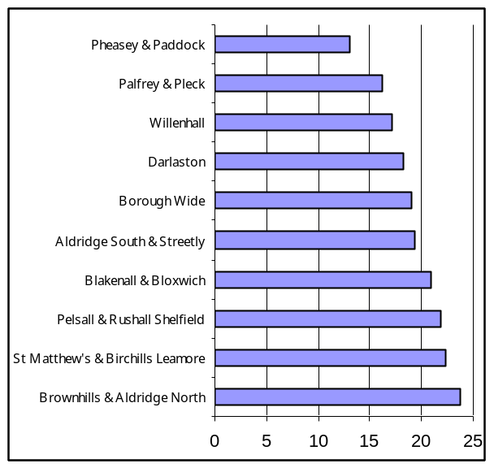 | An estimated 14,621 households (19.1%) in Walsall are in fuel poverty.  The private rented sector has the highest rate (25.4%, 2130 dwellings) reflecting both the low incomes of residents in the sector and the poor energy efficiency of many properties.  42.7% of vulnerable households and 60.6% of unemployed households in the Borough are in fuel poverty (2007 estimates).  The west of the Borough has the highest prevalence of fuel poverty, although it is also an issue in the East of the Borough particularly for older people living in one person households.
Source – Private Sector House Condition Survey 2007, Walsall Council

Key message

Priority Groups whose health is at particular risk from the effects of fuel poverty include:

Elderly people at risk of falls, and/or with pre-existing chronic disease (heart failure, COPD, asthma, diabetes);
Children, particularly those with pre-existing respiratory disease.

Work to develop more systematic approaches to the identification of Walsall residents at risk due to of the effects of fuel poverty need to be extended.

Link to further information:
http://www.walsallpartnership.org.uk/wp-index/wbspwp_useful_documents/wp_jsna.htm

4.8.6 Non-decent housing

A decent home is one which is wind and weather tight, warm and has modern facilities. This is spelt out in more detail in the Decent Homes Standard. A non-decent home is a home which does not meet the Decent Homes Standard.

Figure 41 Rates of Non-Decent Housing by Survey Area, 2007
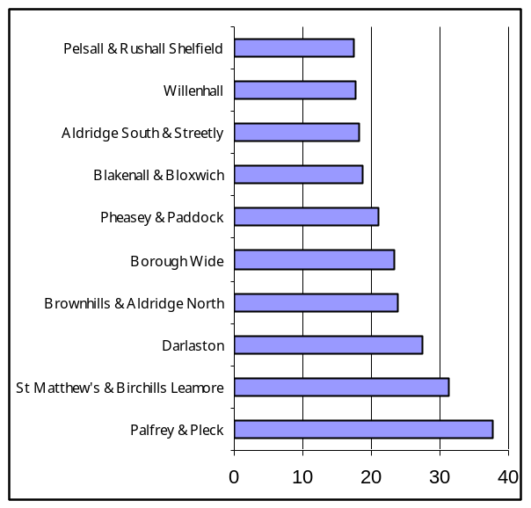 | In 2007, 23.4% of private housing stock in Walsall (almost 19,000 homes) did not meet the decent homes standard.  269 non-decent homes in the private sector were made decent during 2007/08.
Source – Private Sector House Condition Survey 2007, Walsall Council

Key message

Privately rented properties have the lowest average energy efficiency ratings, significantly below the owner occupied sector and social housing. Private sector housing is a clear priority area for work aimed at tackling poor housing in the Borough.

Link to further information:
http://www.walsallpartnership.org.uk/wp-index/wbspwp_useful_documents/wp_jsna.htm

Environmental air quality

Figure 42 Air Quality Management Area for Nitrogen Dioxide (NO₂) | Figure 43 Predicted Annual Mean Nitrogen Dioxide Concentrations (μg m⁻³)
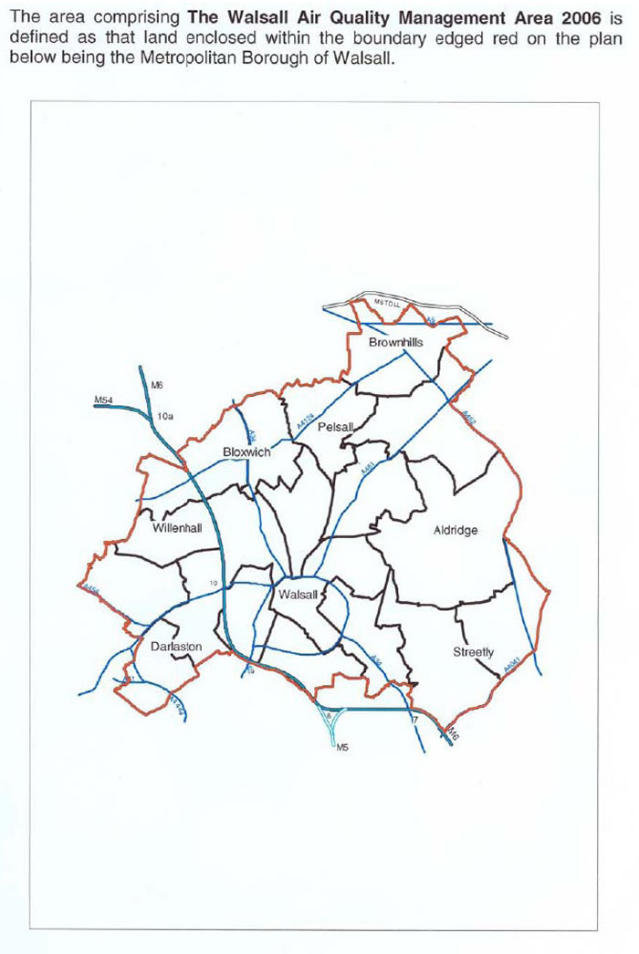 | 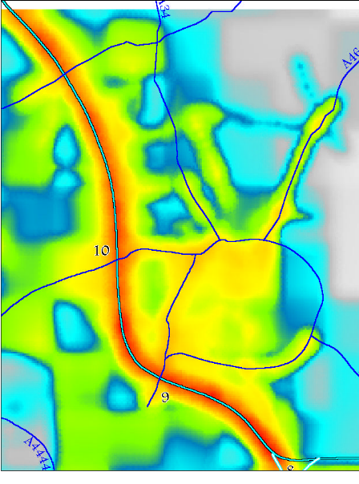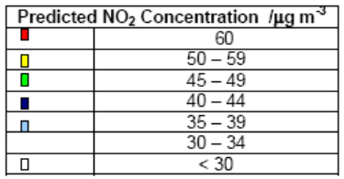
Source – Walsall Council

Key message

Air pollution can have a serious impact on health. Poor air quality can trigger increased admissions to hospital and contribute to the premature death of people who are more vulnerable to daily changes in levels of air pollutants, such as those with lung diseases, and heart conditions. Evidence also suggests that exposure to air pollution can have a long-term effect on health and lead to shortened life expectancy.

Modelling shows that concentrations of nitrogen dioxide (a potent respiratory irritant) are likely to exceed the Air Quality Objective (40 mg m⁻³) along many of the major roads within Walsall (Figure 43). In general, poor air quality is more prevalent in areas to the west of the Borough and this contributes to the burden of health inequalities in the Borough.

So that problems associated with road traffic and transport can be dealt with in an integrated way, Walsall Council has declared the whole of the Borough an Air Quality Management Area for NO_{2.} An AQMA for fine particulate matter (PM10) was also declared in 2008 in a discrete area of Chuckery. Air Quality Action Plans have been developed.

Link to further information:
http://www.walsall.gov.uk/air_quality_updating_and_screening_assessment_2009.pdf

What Have We Already Committed To Do?

The interventions described will have an impact over different timescales:
- Early diagnosis and management of disease and risk factors contributing to early death (mainly in the NHS WCC strategic plan and Annual Commissioning Plan)
- Shaping the physical, social and cultural environment to make healthier choices easier (outcomes included in Walsall LAA)
- Addressing factors contributing to and sustaining poverty and worklessness (Sustainable Community Strategy)

NHS Walsall
NHS Walsall’s Strategic Plan sets out the PCT’s strategic vision, goals, outcomes, programmes and initiatives ‘to add years to life, and life to years’, the vision of World Class Commissioning. The selection of these outcomes and initiatives has been informed by the findings of the Joint Strategic Needs Assessment (2008) and this update, demonstrating greater alignment than ever before between NHS, Local Authority and LSP priorities and actions.

Link to further information:
http://www.walsall.nhs.uk/

Sustainable Community Strategy (SCS)
The SCS is the overarching strategy for Walsall, which sets the high level priorities for the Borough and guides the preparation of other strategies. It is based on needs assessed by a thorough analysis of comparative data and trends and by extensive engagement with residents. While the SCS is set out under three headings – People, Places and Prosperity – it recognises that all are inter-related and the priorities identified within each one will be only delivered through effective partnership working.

The current SCS was approved in summer 2008. It is due to be validated and updated at the end 2010 in order to inform negotiations for a new Local Area Agreement between Walsall and Government. This exercise will draw extensively on the needs and priorities identified in the JSNA, together with similar exercises carried out in other thematic areas.

Link to further information:
http://www.walsallpartnership.org.uk/wp-index/wp_scs.htm

Local Area Agreement (LAA)
Walsall’s current LAA was signed by Ministers at the end of June 2008. It contains 25 main indicators from the National Indicator Set and another 5 local indicators. The selection of indicators was informed by the priorities contained in the SCS which are best delivered in partnership.

At least half of the indicators contained within the LAA either measure health outcomes directly or refer to wider determinants of health.

The LAA is due to be re-negotiated in 2011 and will rely heavily on a revised SCS, which in turn will be informed by the JSNA.

Link to further information:
http://www.walsallpartnership.org.uk/

Are There Gaps in Our Strategic Action Plans to Address Strategic Priorities?

Consultation to date has revealed the following gaps in strategic action plans to address the priorities set out in this document. These and others identified in the consultation process to follow will be considered by the JSNA Core Group and will inform the 2010/11 work programme for the JSNA Delivery Group, which will in turn inform the 2011 JSNA update.

- Public involvement and consultation on priorities
- Development of gap targets
- Identification of priority neighbourhoods using super output area rather than ward based analysis to refine statements about east/ west divide in Walsall
- Clarify and strengthen links and communication between the LSP Board Core Strategy Group and the Walsall Analyst Group (WAG)

Walsall Partnership has developed a joined-up action planning process for delivery of LAA targets. The Partnership Board have agreed to pilot improvements to this process which will address likely pressure on public sector funding and ensure greater coordination of partner activity. These pilots will be developed over the next year.

A new Neighbourhood Management model is being developed which will improve engagement with residents, thus allowing for responsive services and the mechanism for informing residents of what actions have been taken.

Appendices

Appendix 1: Performance Against JSNA Scorecard Indicators

The JSNA scorecard shows some of the key findings of the JSNA through the use of a traffic light code in terms of:
- Indicator / Target
- Current Position
- RAG rating / Progress direction
- Peer Group (a comparator with the average of other PCT’s within the Black Country area – Dudley, Sandwell and Wolverhampton)

The key to the JSNA priorities scorecard is shown in Figure 44

Figure 44 Key for the JSNA scorecard
Indicator / Target | Indicator | Indicator highlighted as plain text
Indicator / Target | Target | Target highlighted as bold text
Progress Direction | ⬆⬆ | Improving
Progress Direction | = | No or little change
Progress Direction | ⬇⬇ | Deteriorating
RAG Rating |  | Current trend on course to meet / exceed target
RAG Rating |  | Moderate risk of current trend not meeting target
RAG Rating |  | High risk of current trend not meeting target
 | - | Currently no target

The scorecard also highlights where key indicators are included as part of Walsall’s Local Area Agreement (LAA) and NHS Walsall’s World Class Commissioning (WCC) outcomes.

There are some indicators highlighted that do not currently have a target, which will need to be addressed.

The scorecard incorporates targets that are included as part of the LAA or WCC. If neither, other targets have been sourced and included such as Vital Signs.

Indicator / Target | LAA | WCC | Current Position | RAG / Progress Direction |  | Peer Group
HEADLINE INDICATORS
All age, all cause mortality - males  (directly standardised mortality rate from all causes, all ages per 100,000 males)  Reduce all age, all cause mortality in males to 659 by 2011 (NI120) | Y | Y | 803.21 (2007) | ⬆⬆ |  | 809.16 (2007)
All age, all cause mortality - females  (directly standardised mortality rate from all causes, all ages per 100,000 females)  Reduce all age, all cause mortality in females to 468 by 2011 (NI120) | Y | Y | 491.33 (2007) | ⬆⬆ |  | 533.75 (2007)
Life expectancy – males  (life expectancy at birth – males)  Reduce by at least 10% the gap between the fifth of areas with the lowest life expectancy at birth and the population as a whole by 2010 | N | Y | 75.7 (05-07) | ⬆⬆ |  | 75.1 (05-07)
Life expectancy – females  (life expectancy at birth – females)  Reduce by at least 10% the gap between the fifth of areas with the lowest life expectancy at birth and the population as a whole by 2010 | N | Y | 81.3 (05-07) | ⬆⬆ |  | 80.7 (05-07)
STRATEGIC PRIORITIES FOR IMPROVING HEALTH AND WELL-BEING
IMPROVING HEALTH & LIFE CHANCES FOR BABIES, CHILDREN & YOUNG PEOPLE
Infant mortality  (deaths under 1 year per 1,000 live births)  Starting with children under 1 year, by 2010 to reduce by at least 10% the gap in infant mortality between the routine and manual groups and the population as a whole | N | Y | 8.4 (05-07) | ⬇⬇ |  | -
Under 18 conception rates  (conceptions per 1,000 females aged 15 – 17 years)  Reduce under 18 conception rates to 30.2 by 2011 (NI112) | Y | Y | 54.5 (2007) | ⬆⬆ |  | 57.5 (2007)
Childhood obesity  (% of obese children in YR and Y6)  Reduce obesity amongst primary school age children in Year 6 to 18.6% by 2010/11 | Y | Y | 31.2% (08/09) | ⬆⬆ |  | 34.1% (08/09)
IMPROVING EARLY DETECTION & EFFECTIVE TREATMENT OF MAJOR KILLERS TO IMPROVE LIFE EXPECTANCY
Circulatory Disease  (directly standardised mortality rate per 100,000 persons aged under 75)  Substantially reduce the mortality rates by 2010 from heart disease and stroke and related diseases by at least 40% in people under 75, with at least a 40% reduction in the inequalities gap between the areas with the worst health and deprivation indicators and the population as a whole | N | N | 95.6 (2007) | ⬆⬆ |  | 101.81 (2007)
Cancer  (directly standardised mortality rate per 100,000 persons aged under 75)  Substantially reduce cancer mortality rates by at least 20% in people under 75, with at least 6% reduction in the inequalities gap between the fifth of areas with the worst health and deprivation indicators and the population as a whole | N | N | 123.8 (2007) | ⬆⬆ |  | 120.04 (2007)
LIVING HEALTHIER LIVES WITH LONG-TERM ILLNESS
Cardiovascular disease  (age standardised mortality rate per 100,000 persons aged 65 to 74)  Substantially reduce the mortality rates by 2010 from heart disease and stroke and related diseases by at least 40% in people under 75, with at least a 40% reduction in the inequalities gap between the areas with the worst health and deprivation indicators and the population as a whole | N | Y | 306.7 (2007) | ⬆⬆ |  | 384.34 (2007)
Diabetes  (estimated diabetes prevalence)  Currently no target | N | N | 5.4% (07/08) | - |  | -
Chronic Obstructive Pulmonary Disease  (estimated COPD prevalence)  Currently no target | N | N | 1.8% (07/08) | - |  | -
PROMOTING HEALTHY AGEING
Stroke  (estimated stroke prevalence)  Reduce stroke incidents in Walsall | N | Y | 1.6% (07/08) | ⬆⬆ |  | -
Fractured Neck of Femur  (hospital admissions per 100,000 population)  Currently no target | N | N | - | - |  | -
Dementia  (estimated number of people with dementia)  Currently no target | N | N | 3,137 (2007) | - |  | -
Excess Winter Deaths  Decrease the Excess Winter Deaths Index in adults aged 65 and over | N | N | 14.1 (07/08) | ⬇⬇ |  | -
REDUCING INEQUALITIES IN LIFESTYLE
Smoking  (estimated smoking prevalence)  Reduce adult (16+) smoking rates to 21% or less by 2010, with a reduction of prevalence among routine and manual groups to 26% or less by 2010 | N | Y | 21% men 20% women (2005) | ⬆⬆ |  | -
Physical activity in adults  (% adults participating in sport and active recreation of at least 30 minutes duration on 3 or more days a week)  Increase the % of adult population who participate in sport to 20.1% by October 2011 (NI8) | Y | N | 18.9% (08/09) | ⬆⬆ |  | -
Obesity in adults  (estimated % of obese adults)  Patients aged 15 to 75 with BMI recording in the last 15 months  Patients aged 15 to 75 with a BMI of over 30 in the last 15 months | N | Y | c. 19% - 33% (2005) | = |  | -
PROMOTING & IMPROVING WELL-BEING, MENTAL HEALTH & QUALITY OF LIFE
Alcohol related admissions  (alcohol related harm hospital admissions per 100,000 population)  Reduce the number of hospital admissions for alcohol related harm to the national average by 35% by 2010 | N | Y | 2000.00 (08/09) | ⬆⬆ |  | 1866.67 (08/09)
Suicide  (age standardised mortality rates, all persons, all ages for suicide and undetermined injury per 100,000)  Reduce mortality rates by 2010 from suicide and undetermined injury by at least 20% | N | N | 7.6 (05-07) | = |  | 7.8 (05-07)
Safety and Fear of Crime  (% people who think anti-social behaviour is a problem in their local area)  Improve public perceptions of anti-social behaviour to 29.8% by 2010 (NI17) | Y | N | 26.1% (08/09) | = |  | -
PROMOTING INDEPENDENCE, SOCIAL ISOLATION, CARE & SAFEGUARDING VULNERABLE PEOPLE
Incapacity Benefit claimants  (number of claimants)  Currently no target | N | N | 7,140 male  4,930 female (May 09) | - |  | -
Disability Living Allowance claimants  (number of claimants)  Currently no target | N | N | 8,090 male  8,270 female (May 09) | - |  | -
Older people living alone  (number older people aged 50+ living alone)  Increase the number of people supported to live independently through social services to 3,000 by 2010/11 | Y | N | 6,482 male  13,140 female  (2001) | - |  | -
Population living in residential care  (number of people living in residential care)  Currently no target | N | N | 677 male  1,288 female (2001) | - |  | -
PROSPERITY: IMPROVING LIFE CHANCES FOR THE PEOPLE OF WALSALL
GCSE attainment  (% 15 year olds achieving 5+ GCSEs or equivalent at A*-C, including English and Maths)  Currently no target | N | N | 40.6% (2008) | - |  | -
Jobseekers Allowance claimants*  (proportion of claimants as a % of working age population)  Reduce the proportion of working age people on out of work benefits to 15.0% by 2010/11 (NI152) (*JSA claimants one of the benefits included) | Y | N | 7.5 (Oct 09) | ⬇⬇ |  | 7.3 (Oct 09)
Working age with NVQ2 or above  (proportion of working age with NVQ2 or above)  Increase the proportion of working age population qualified to at least level 2 or higher (NI163) | Y | N | 56.1 (2008) | = |  | -
Not in Education, Employment or Training (NEET)  (proportion of 16 to 18 years olds not in education, employment or training)  Increase 16 to 18 year olds who are NEET to 8.7% by 2010/11 (NI117) | Y | N | 9.1% (Q2 09/10) | ⬆⬆ |  | -
Child Poverty  (proportion of children in poverty)  Reducing the proportion of children in poverty to 22.5% by 2010/11 (NI116) | Y | N | 25.7% (2007) | ⬇⬇ |  | -
Fuel Poverty  (% households in fuel poverty)  Reducing the % of people receiving income based benefits living in homes with a low energy efficiency rating to 2.4% in 2010/11 (NI187) | Y | N | 19.1% (2007) | - |  | -
Non-decent housing  (% of non-decent housing)  All public sector housing to be of a decent standard by 2010 | N | N | 23.4% (2007) | - |  | -
Air quality  Per capita reduction in CO2 emissions in the Local Authority area | Y | N | - | - |  | -

Appendix 2: Small Area Analysis

In order to support prioritisation and planning at Practice Based Commissioning (PBC) Cluster / Local Neighbourhood Partnership (LNP) area / Children’s Area Partnership (CAP) and other small areas, a range of reports and profiles are available / can be produced within Public Health.
For example:

1. Practice Based Commissioning Health Inequalities Profile
These reports include:
- Introduction
- Demography
  - Geography
  - Age and gender
  - Ethnicity
  - Socio-economic status (deprivation)
  - Housing
- Life Expectancy
  - Walsall life expectancy at birth
  - PBC life expectancy at birth
  - Priorities and action plan (wards)
- Infant Mortality & Child Health
  - Infant mortality in Walsall
  - Early booking for antenatal checks
  - Breastfeeding uptake in Walsall
  - Smoking in pregnancy
  - Immunisation uptake (MMR & Polio/Hib/MenC)
  - Maternal age
- Long-term Conditions
  - PBC Prevalence for QOF clinical domains
  - Variation in LTC prevalence
  - CHD risk stratification
  - Prescribing and long-term conditions
- Acute activity
  - Day-case admissions
  - Elective admissions (in-patients)
  - Emergency admissions
  - Non-elective length of stay
  - Outpatient admissions
- Lifestyles
  - Smoking prevalence
  - Obesity – adults
  - Obesity – children
  - Physical activity profiles

An example of PBC Health Inequalities profiles can be accessed here: http://intranet.pct.xwalsall.nhs.uk/PracticeBasedCommissioning/PBCNorthClusterPHNA.asp

Profiles for the other clusters can be accessed via the appropriate cluster web pages: http://intranet.pct.xwalsall.nhs.uk/PracticeBasedCommissioning/PBCHomepage.asp

2. Local Neighbourhood Partnership Demographic and Health Profiles
The profiles include:
- Health headlines
- Demography
- Health inequality issues
- Lifestyles and choosing health
- Child health
- Long-term conditions and hospital
- Map of health services in the LNP
- Mental health
- Summary LNP information compared to Walsall

All 9 of the LNP Demographic and Health Profiles can be accessed here: http://www.walsallpartnership.org.uk/wp-index/wbspwp_useful_documents/wp_jsna.htm

3. Children’s Area Partnership Profiles
The profiles include:
- Demography
- Findings from Indices of Deprivation 2007 Income Deprivation Affecting Children Index score predictions
- Maps
- Health data

All 16 of the CAP profiles can be accessed here:
http://www.walsallpartnership.org.uk/wp-index/wbspwp_useful_documents/wp_jsna.htm

4. Practice Based Analysis
Analyses based on individual GP practices is available to the practice staff upon request,

5. Health Needs Assessment
Health Needs Assessments for specific areas within Walsall are regularly produced and consist of:
- Executive summary
- Introduction
- Demographic profile
- Wider determinants of health
- Health status
- Choosing health and healthy lifestyles
- Long term conditions
- Screening
- Children and maternity
- Primary care services
- Other services – social care
- Summary
- Recommendations

The most recently completed Health Needs Assessment is for Mossley / Dudley Fields. This can be accessed here:
http://www.walsallpartnership.org.uk/wp-index/wbspwp_useful_documents/wp_jsna.htm
Further customised analyses can be requested in consultation with Borough analysts through the Walsall Analysts Group.

Vulnerable households are defined as households containing children, those that are elderly, chronically sick, or living with a disability.

