7.2 Cancer

Cancer is the leading cause of death in under-75s in Walsall. Over 29% of all premature deaths in the borough in 2012 are due to cancer (there were 360 premature deaths to cancer in 2012).

The chart below shows that premature mortality from cancer has decreased for both women and men over the period in the graph below. Premature Cancer mortality for males has decreased by 11%, while females have decreased by 4%. In 2010, both genders premature mortality rate was greater than that for England.

Figure 1 Premature Mortality from all Cancers. (Source: Public Health Outcomes Framework)

Indicators:

Mortality rate from cancer, ages under 75, per 100,000 population varies across the borough, with male rates in Blakenall, Darlaston South and Birchills Leamore more than double the rates in Paddock and Streetly and female rates in Bloxwich East, Blakenall, Pelsall and Darlaston South more than double the rates of Pheasey, Aldridge Central and South, Aldridge North and Walsall Wood, Birchills Leamore and Pleck. The commonest types of fatal cancers in Walsall are lung, colorectal, oesophageal, breast, prostate and stomach. In the 2012-13 NHS Outcomes Framework, the survival rates at 1 year and 3 years are being reported on for three of the major cancers: colorectal, breast and lung.

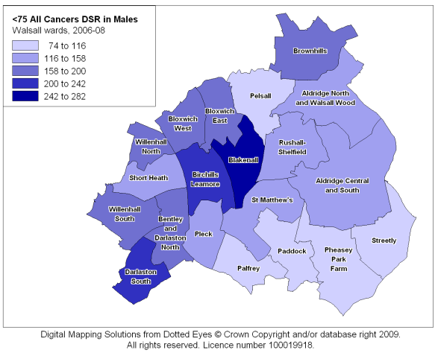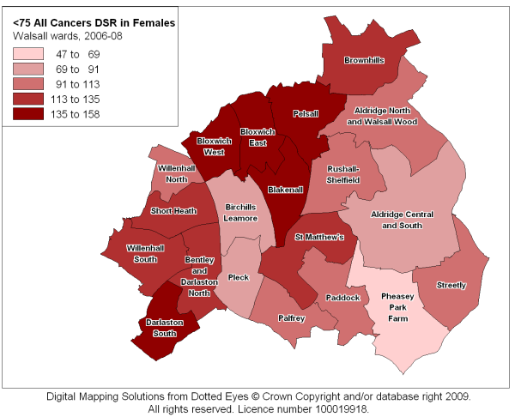
Figure 2 Under 75’s all cancer DSR by community - Males (left) and Females (right) (Source: Public Health Mortality File)

Priorities for action:

A wide variety of factors can help to reduce the risk of cancer, aid early diagnosis and offer prompt and effective treatment. Modifiable population risk factors include stopping smoking, improving diet, keeping alcohol consumption moderate and engaging in physical activity. Nearly 90% of the 150 cases of lung cancer that occur each year in Walsall are due to smoking, so if everyone stopped smoking in Walsall there would be 128 fewer cases each year. A further 90 cancers of oesophagus, stomach and bowel could be prevented by healthier diets and reduction in obesity. Potentially 45% of the 670 cancers diagnosed in Walsall each year could be avoided by modifying simple lifestyle risk factors.

National public health screening programmes are in place to support and improve the early detection and treatment of breast, bowel and cervical cancer. These are having a significant impact on cancer survival, but not everyone eligible attends.

Bowel screening
For the 6 months up to February 2013, 51.0% of 60-74 year olds took up bowel screening. This is an decrease on the previous year’s uptake of 52.8% (at Feb 2012). The target as shown in the Health Protection Dashboard is 60% uptake.

The 2.5 year coverage rate for 60-74 year olds has increased from 52.9% in Feb 2012 to 54.6% in November 2013. The target as shown in the Health Protection Dashboard is 60% coverage.

Cervical screening
The Walsall coverage rate has dropped slightly from 74.94% in 2010 to 73.1% in December 2013. This is for those aged between 25 and 64 years, over a 3.5/5.5 year coverage. The target as shown in the Health Protection Dashboard is for 80% coverage.

Breast screening
In Walsall, the uptake in breast screening (for 50 to 70 year olds) has reduced from 73.8% in Feb 2012 to 77.8% in December 2013. This is still above the 70% target seen in the Health Protection Dashboard.

The 36 month coverage rate however has increased from 69.1% in Feb 2012 to 72.6% in December 2013. Again, this is above the 70% target as seen in the Health Protection Dashboard.

Recommendations to target areas of lower than average uptake will increase the numbers of people with cancer diagnosed sooner, and hence treated when their cancer is at an earlier and more easily treated stage.

Effectiveness of treatment depends on speed of diagnosis, quality of and compliance with treatment and mitigation of social isolation. There is increasing evidence that people with poor social networks, isolation and depression have poorer survival rates than those without.

We should therefore ensure, where possible, that patients are offered the necessary social support to maximise their chances of survival.

Site | New cases per year |  | Attributable fraction |  | Potentially avoidable
 | Males | Females | Male % | Female % | Males | Females
Lung | 91 | 59 | 87% | 84% | 79 | 49
Colorectal | 38 | 28 | 57% | 52% | 22 | 15
Oesophagus | 28 | 13 | 90% | 88% | 25 | 11
Stomach | 18 | 8 | 78% | 69% | 14 | 6
Breast | - | 51 | - | 27% | 0 | 14
Bladder | 15 | 6 | 44% | 37% | 7 | 2
Leukaemia | 10 | 6 | 16% | 14% | 2 | 1
Melanoma | 4 | 2 | 90% | 82% | 4 | 2
Other | 123 | 126 | [-] | [-]
All | 371 | 300 | 45% | 40% | 168 | 120
Figure 3 Walsall impact on cancer of eliminating common risk factors: Potentially avoidable cases per year

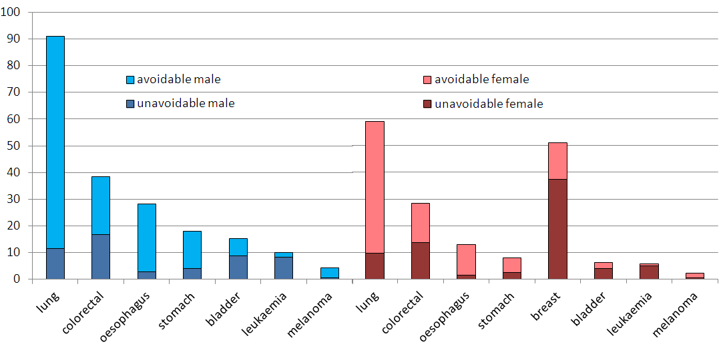
Figure 4 Walsall potential avoidable and unavoidable cancers by gender - impact of eliminating common risk factors

