6.3 Smoking cessation and tobacco control

Smoking is still the single greatest cause of illness and premature death in England, killing one in two smokers prematurely. For each cigarette smoked, a smoker’s life span is shortened by about five minutes. Those who die as a result of a smoking related illness will have lost, on average, 10-15 years of life. According to Walsall’s Tobacco Profile for 2016, there were 310 smoking related deaths in Walsall per 100,000 population (for the period of 2012-2014). This has reduced from 318 for the period 2010-12 but is still significantly higher than the England average of 275 deaths per 100,000 (2012-14) and when compared to the West Midlands Region.

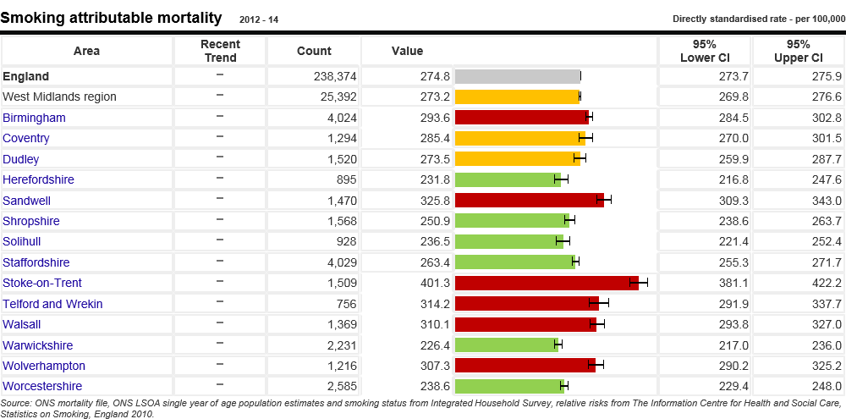

In March 2011 the Government launched its Healthy Lives, Healthy People: a Tobacco Control Plan for England. The plan outlines the key elements for work to address tobacco use from Government level down to local communities, which are stopping the promotion of tobacco, making tobacco less affordable, effective regulation of tobacco products, helping tobacco users to quit, reducing exposure to second hand smoke and effective communications for tobacco control. The plan also outlines 3 national ambitions:

- To reduce adult (aged 18 or over) smoking prevalence in England to 18.5% or less by the end of 2015, meaning around 210,000 fewer smokers a year
- To reduce rates of regular smoking among 15 year olds in England to 12% or less by the end of 2015
- To reduce rates of smoking throughout pregnancy to 11% or less by the end of 2015 (measured at time of giving birth)

These ambitions have now been translated into measures in the Public Health Outcomes Framework and will form the basis of our strategic plan which is currently in development.

Indicators:

The estimated prevalence for smoking within the Walsall population is 17.6%. The national average is 16.9% and regional average is 15.7% (Local Tobacco Control Profile, period 2015).

Rates of young people’s smoking are reported to be rising nationally but local figures are unclear at the moment. The spine chart below illustrates the most recent data collected on smoking prevalence and use of tobacco products amongst Walsall’s younger population. Smoking prevalence at age 15 – regular smokers in Walsall is 5.9% compared to the England value of 5.5%. Stop Smoking Services are available to smokers from the age of 12 and we plan to do an analysis of quitters aged 15 and under to gather further insight into this group.

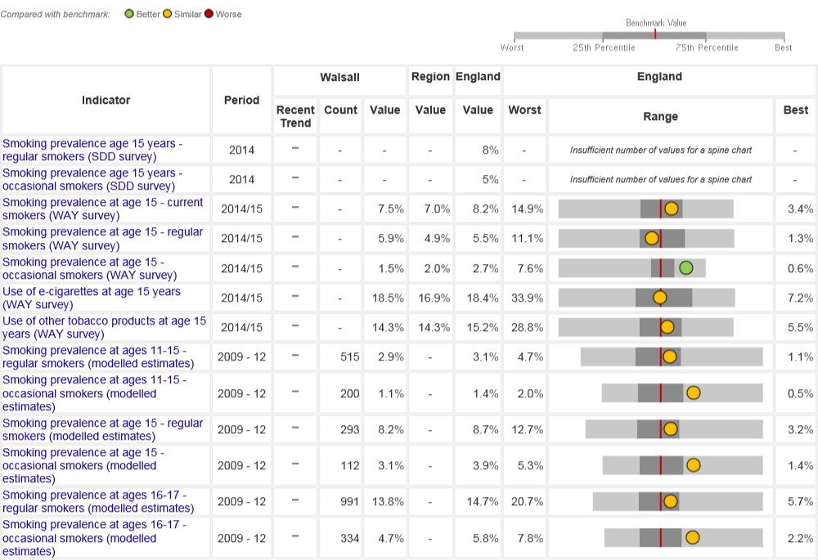
Source: Local Tobacco Control Profiles, Public Health England

Rates of smoking during pregnancy are estimated from figures gathered at time of delivery.
In line with the general population, smoking prevalence has been high in Walsall but in the last 12 months huge improvements have been made within maternity services. The rate of women who were reported as smokers at the time of delivery at end of March 2013 had fallen to 15.7%. This downward trend has continued throughout the 2013/14 period to 13.7%. However, this is still high compared to the regional rate (13.2%) and the national rate (12.0%) for the same period.

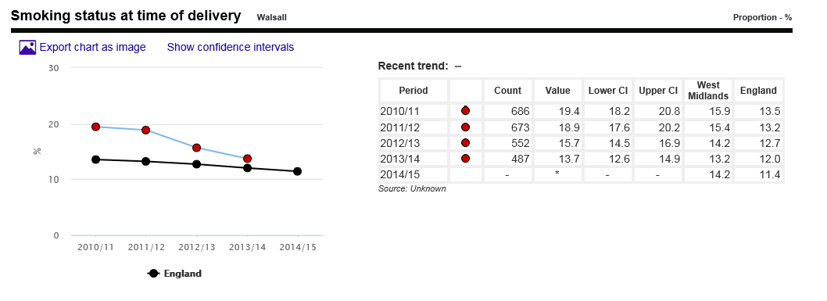
Source: Local Tobacco Control Profiles, Public Health England

Between 2010/11 and 2011/12, costs for hospital admissions for smoking related conditions were reduced from £4.8m to £4.6m (Walsall CCG analysis).

The numbers of people stopping smoking has remained constant following the high numbers produced by the introduction of the ban on smoking in public places in 2007. Walsall is performing significantly better in three out of the five indicators. However, a focus needs to be placed on cost per quitter and completeness of NS-SEC recording by Stop Smoking Services indicators to improve them inline with the national values.

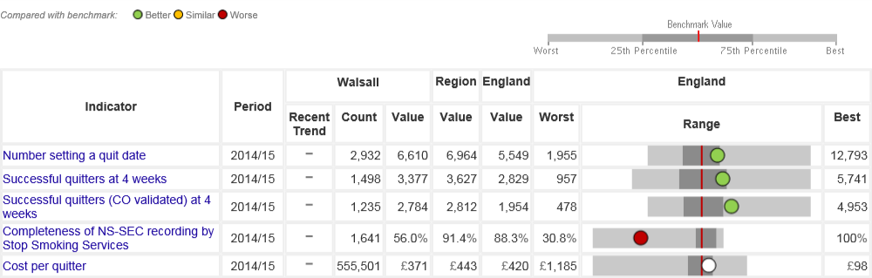
Source: Local Tobacco Control Profiles, Public Health England

An emerging trend is the use of electronic cigarettes (e-cigs). These are a method for nicotine delivery (generally described as Electronic Nicotine Delivery Systems (ENDS). A review of the evidence commissioned by Public Health England (PHE) in 2014 found that the hazard associated with electronic cigarette products currently on the market “is likely to be extremely low and certainly much lower than smoking”.

Action on Smoking and Health (ASH) report, The Smoking Toolkit Study, which provides information about smoking prevalence and behaviour in England, found that electronic cigarettes have overtaken over-the-counter (OTC) nicotine replacement therapy (NRT) as the first choice of stop smoking aid. The study suggested they are 60% more effective in helping smokers quit than NRT bought OTC or quitting unaided. The Smoking Toolkit Study estimates, that in 2014, electronic cigarettes resulted in 20,000 more people quitting smoking who otherwise would not have done so.

Public Health England recommends that smokers who have tried other methods of quitting without success be encouraged to try electronic cigarettes and that Stop Smoking Services should support smokers using electronic cigarettes to quit by offering them behavioural support. This is supported by recent data which shows that smokers using the English Stop Smoking Services who quit whilst using electronic cigarettes have reported higher quit rates at 4-weeks than smokers using other quitting aids.

Priorities for action:

Our overall aim is to have fewer people smoking. Research shows that at any one time 63% of smokers want to stop which would give us around 35,000 potential users of stop smoking services in Walsall against the 3,785 people who used the services in 2013/14, therefore, there is a high level of unmet need.

Key priorities are:
- To achieve the target of 2450, 4 week quitters by end March 2015
- To maintain Stop Smoking Services provision through re-procurement of the contract during 2013 for delivery of services from April 2014
- To review and refresh the Tobacco Control Plan for Walsall to establish a multi agency coordinated approach to implementing ambitions in the National Strategy locally emphasising prevention
- To establish a baseline for number of under 15’s who smoke and to review current activity to ensure that work with young people in all settings includes action on smoking, to address issues associated with this target group
- To address with all groups in the community the issues around use of Shisha, chewing tobacco and electronic cigarettes
- To continue to tackle the supply of counterfeit tobacco products in the shadow economy
- To continue to implement the Smoke Free legislation through statutory visits to local business.

