7.8 Health Protection

Infections continue to be a significant cause of ill health. In 2010 in England, infectious diseases accounted for 7% of all deaths, 4% of all potential life years lost (to age 75) and were also the primary cause of admission for 8% of all hospital bed days. They are responsible for a large proportion of sickness absence from work. The burden of disease and economic impact of infections and infectious disease is estimated at £30 billion each year in England. A characteristic of infectious disease, which separates it from other types of illness, is that the causative factors undergo rapid change, developing resistance and the emergence of new pathogenic organisms.

The challenge of reducing healthcare associated infections
The Department of Health requires the Clinical Commissioning Groups (CCG) to have no more than 72 cases of Clostridium difficile across Walsall in 2013/14. This includes Walsall Healthcare Trusts allowance of 28. Despite many interventions and successes there has been a slight increase in the number of Clostridium difficile infections since December 2012, as seen in Figure 1 below.

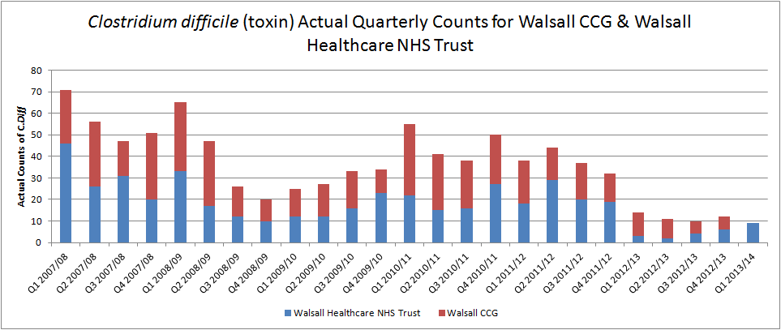
Figure 1 C. Difficile actual quarterly counts for Walsall CCG and Walsall Healthcare NHS Trust
Source: PHE (http://www.hpa.org.uk/web/HPAweb&HPAwebStandard/HPAweb_C/1195733750761)
& (http://www.hpa.org.uk/web/HPAweb&HPAwebStandard/HPAweb_C/1195733750761)
Please note as of April 2013 Primary Care Organisations (PCOs) ceased to exist and were replaced by Clinical Commissioing Groups (CCGs).
Therefore data published monthly is now reported by CCG rather than PCO. Archive monthly outputs reporting data to the end of March 2013 are still by PCO.

The numbers of blood infections caused by Meticillin resistant Staphylococcus aureus (MRSA) has been falling for a number of years, as seen in Figure 2 below. There have been 2 patients identified as having an MRSA blood stream infection reported as of October 2013.
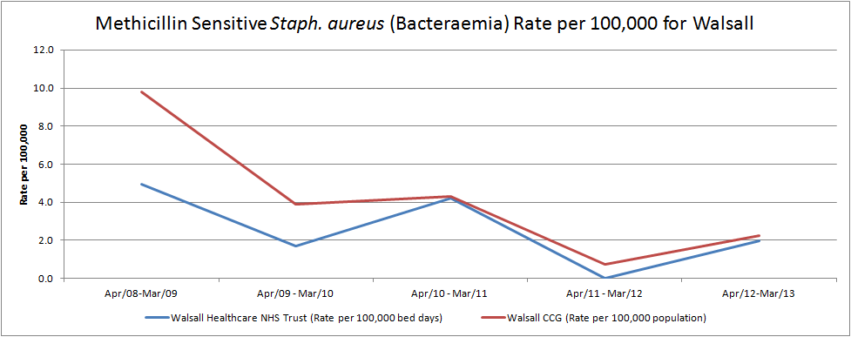
Figure 2 MRSA Infections per 100,000 population
Source: PHE (http://www.hpa.org.uk/web/HPAweb&HPAwebStandard/HPAweb_C/1233906819629)
* At the time of rates production PCO population estimates for 2012 were unavailable. 2012/13 rates are thus based upon 2011 population data.

An analysis of the cases of Clostridium difficile and MRSA blood stream infections (bacteraemia) has identified themes that are being addressed by the care providers within Walsall health economy. These include issues with antimicrobial prescribing, environmental cleanliness in healthcare and residential care home settings, adherence to infection prevention practices and improving communication between care providers.

Immunisation against childhood diseases
The uptake of childhood immunisations remains very high in Walsall at over 95%. This high uptake needs to be continued to ensure ongoing immunity within the Walsall population because there have been outbreaks of measles and whooping cough reported nationally. This year there have been changes in the vaccine schedule to include removal of the Men C vaccine at 4 years old to be replaced with a Men C vaccine for school leavers. This vaccine will be undertaken by the school nursing teams. A new vaccine was introduced in July 2013 to protect babies from rotavirus, this will be given at 3 months old. Finally a new shingles vaccine has been introduced for all 70 year olds with a catch up programme for 79 year olds.

Tuberculosis (TB)
Figure 3 shows the rates per 100,000 population since 2002 and shows a relatively stable picture whereas Sandwell and Wolverhampton appear to have increasing numbers.
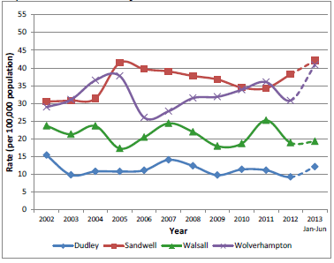
Figure 3 Tuberculosis rate per 100,000 population

It is essential that patients started on anti TB treatment complete the course due to the risk of developing resistance to the antibiotics. In 2012, 100% of patients who commenced on treatment finished the full course.
In addition to reacting to infections, proactive TB control involves identification of neonates at high risk of acquiring infection. Further work is required to ensure that high risk neonates are offered the BCG TB vaccine at the earliest opportunity.

Influenza
Last winter was another quiet flu season for England. However, some other countries experienced more severe flu, a reminder that flu can be dangerous and remains highly unpredictable. Figure 4 below shows the uptake of flu vaccine amongst the high risk groups compared to the achievements of surrounding organisations.
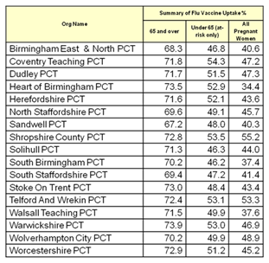
Figure 4 Flu vaccine update summary by PCT
Our main challenges in Walsall are to increase the number of people under the age of 65 in at risk groups and pregnant women receiving flu vaccine this winter.
The flu vaccine programme seeks to protect high risk people from flu by vaccinating them and also their carers. Work is undertaken each year to encourage uptake of vaccine amongst health and social care staff who have direct contact with patients. In addition a vaccine for 2 and 3 year olds has been introduced.

Health Emergency Planning

Public Health in the Local Authority will be responsible for ensuring plans and arrangements are in place to respond to emergencies involving a risk to public health. The Director of Public Health will lead both on ensuring all health protection plans are in place, and the provision of public health advice on health protection plans within the Local Authority.

Since transition a number of risks have been identified outlining gaps within response structures, roles and responsibilities, and the resources available in dealing with any incidents triggering risk to the health of the public.

A Health Protection Forum chaired by the DPH is in place to allow an assurance process to be carried out concerning health protection over internal and external partners in mitigating against these risks.

